FlavourFlow



Project ID: Fall-2025-00
Session: BSCS Fall 2021 to 2025
Project Advisor: Mishal Muneer, M. Ali Ilyas
Submitted By
Muhammad Usman | 70140621
Muhammad Haroon Hanif | 70138188
Abdul Mateen | 70137808

Department of Computer Science & IT
The University of Lahore
Lahore, Pakistan

Declaration
We have reviewed and have a full understanding of the project guidelines and the definition of academic dishonesty, specifically plagiarism and collusion. We acknowledge that the submitted document, FlavourFlow, was created specifically for the purposes of our final year project, has not been reproduced or published in any form, and has never been submitted or presented for publication or any other research.
Group Member 1 Name: Muhammad Usman
SAP No: 70140621

Signature: _______________________

Group Member 2 Name: Muhammad Haroon Hanif
SAP No: 70138188

Signature: _______________________

Group Member 3 Name: Abdul Mateen
SAP No: 70137808

Signature: _______________________

Statement of Submission

This is to certify that Muhammad Usman Roll No. 70104621, Muhammad Haroon Hanif Roll No. 70138188 and Abdul Mateen Roll No. 70137808 have successfully submitted the final year project titled “FlavourFlow” at the Department of Computer Science & IT Campus, to fulfill the partial requirement of the degree of BS in Computer Science.

Supervisor Name: Mishal Muneer & M. Ali Ilyas

Signature: ________________________

Signature: _______________________

Date: __________________

Dedication

This project is for our mother. She is a special person. Our mother has always been there for us praying for us and making sacrifices for our benefit. Her love for us has no limits. Our mother has helped us become the people we're today. We have learned a lot from her. She is very strong and brave. Our mother has shown us how to deal with times and how to feel happy about our successes. Our mother is a part of our lives and we are grateful, for her guidance and love. We think about our mother and all that she does for us every day.

We want to thank every chef, food creator, home cook and culinary artist. They inspire students and people who're not in a classroom. This includes YouTube chefs, people who write recipe blogs and food vloggers. We are talking about every person who teaches people how to cook, shares recipes and spreads the love of cooking. The YouTube chefs, recipe bloggers, food vloggers and culinary artists are very creative. They make it easy for people, like us to learn how to cook. They help us try things and get better at cooking on our own. The chefs, food creators, home cooks and culinary artists have really helped us.

Lastly, this dedication extends to all individuals who strive to balance life, education, and daily meals, especially students living away from home — may this application serve as support, inspiration, and a digital companion on their journey.

Acknowledgement
First and foremost, we bow our heads in gratitude to Almighty Allah, who blessed us with strength, health, and opportunities to complete this project.
We are sincerely thankful to our respected supervisor, Mishal Muneer & M. Ali Ilyas, for continuous guidance, valuable feedback, and support, without which the successful completion of this project would not have been possible.
We express gratitude to all faculty members and the Department of Computer Science & IT for providing us with knowledge, resources, and encouragement throughout our degree program.
A special thanks to our parents, whose prayers, patience, support, and love have been the foundation of our success. We also acknowledge our friends & classmates for their moral support, contributions, and shared journey throughout this project.
May Allah reward them all abundantly.

Date: ________________

Abstract
FlavourFlow is an app that utilizes AI to assist with cooking and meal preparation. This app simplifies your daily mealtime preparation and shopping by suggesting recipes based on what you already have on hand, and connecting you with other users through a social network to create a community where you can share cooking experiences. You can search for recipes, generate a meal from what you currently have in your pantry; you can also manage your pantry using an organized inventory of everything in your pantry, including the nutritional value of what is on your shelves. Additionally, you will have access to an interactive digital assistant that will guide you through each step of the cooking process in real-time via a hands-free interface. FlavourFlow was designed by utilizing advanced technology and utilizes AI algorithms for personalized recommendations based on the ingredients in your pantry and personal preferences.
Some of the features included in FlavourFlow are ingredient-based suggestions, a voice-to-text mode for cooking instructions, the ability to upload your own recipes and a social dashboard where users can post photos, comments, and share their cooking experiences with the FlavourFlow community. The goal of this project is to decrease the amount of stress related to the meal preparation process, stimulate creativity in meal preparation, and to help individuals become better organized and efficient at managing their meal preparation and cooking business. The use of FlavourFlow technology and ease of use allows countries across the globe to develop their own digital cooking culture; there are also certain groups of users (e.g. college students and people with busy schedules) who will benefit greatly from using FlavourFlow.

Area of the Project

- Mobile Application (Android / iOS)

Technologies used

- React Native(Frontend – Cross platform UI)
- Python
- TypeScript
- Firebase /Clerk (Authentication)
- Supabase (Backend – Database)
- Android Studio (Android Development Tools)
- XCode (IOS Development Tools)
- VS Code

List of Figures:

Figure ‎3.1-1: System Use Cases 16
Figure ‎3.1-2: Account Management 17
Figure ‎3.1-3: User Preference Management 19
Figure ‎3.1-4: Meal Recommendation 20
Figure ‎3.1-5: Search Recipes 22
Figure ‎3.1-6: Recipe Interaction 24
Figure ‎3.1-7: Community Dashboard 25
Figure ‎3.1-8: Recipe Upload and Management 27
Figure ‎3.1-9: Rate and Review 28
Figure ‎3.1-10: Find Recipes from Ingredients 30
Figure ‎3.1-11: Start Cooking 31
Figure ‎3.1-12: Trending and Popular Recipes 33
Figure ‎3.1-13: Manage Application Settings 35

List of Tables:

Table ‎2.3-1: Account Management 7
Table ‎2.3-2 User Preference 7
Table ‎2.3-3 Personalized Meal Recommendation System 8
Table ‎2.3-4 Recipe Search and Discovery 9
Table ‎2.3-5 Recipe Interaction & Engagement 9
Table ‎2.3-6 Community Dashboard & Social Feed 10
Table ‎2.3-7 User Recipe Contribution 11
Table ‎2.3-8 Feedback & Rating System 11
Table ‎2.3-9 Smart Pantry & Ingredient Insights 12
Table ‎2.3-10 Cooking Assistance 12
Table ‎2.3-11 Trending & Popular Recipe Display 13
Table ‎2.3-12 Application Settings & Localization 14
Table ‎2.3-13: NFR 14
Table ‎3.1-1: Use Case – 1: Account Management 18
Table ‎3.1-2: Use Case – 2: User Preference Management: 20
Table ‎3.1-3: Use Case – 3: Generate Meal Recommendation System 21
Table ‎3.1-4; Use Case – 4: Search Recipes 23
Table ‎3.1-5: Use Case – 5: Recipe Interaction & Engagement 25
Table ‎3.1-6: Use Case – 6: Community Dashboard 26
Table ‎3.1-7: Use Case – 7: User Recipe Upload & Management 28
Table ‎3.1-8: Use Case – 8: Feedback & Rating System 29
Table ‎3.1-9: Use Case – 9: Find Recipes from Ingredients 31
Table ‎3.1-10: Use Case – 10: Start Cooking 33
Table ‎3.1-11: Use Case – 11: Show Trending & Popular Recipe 34
Table ‎3.1-12: Use Case – 12: Manage Application Settings 35

Table of Contents

Declaration ii
Statement of Submission iii
Dedication iv
Acknowledgement v
Abstract vi
Technologies used vii
List of Figures: viii
List of Tables: ix
1. Chapter 1: Introduction to the Problem: 16
1.1 Introduction: 16
1.2 Purpose: 16
1.3 Objectives: 17
1.4 Existing Solution 17
1.5 Proposed Solution 20
2. Chapter 2: Software Requirement Specification 22
2.1. Introduction: 22
2.1.1. Purpose: 22
2.1.2. Scope 22
2.1.3. Definitions, Acronyms, and Abbreviations 22
2.2. Overall Description 24
2.2.1. Product Perspective 24
2.2.2. Product Functions 24
2.2.3. User Characteristics 25
2.2.4. Constraints 25
2.2.5. Assumptions and Dependencies 25
2.2.6. Apportioning of requirements 26
2.3. Specific Requirements 26
2.3.1. Functional Requirements 26
2.3.2. Non-functional Requirements: 34
3. Chapter 3: Use Case Analysis: 36
3.1. Use Cases: 36
4. Chapter 4: Design: 59
4.1 Architecture Diagram 59
4.2 ERD with data dictionary: 60
4.3 Data Flow Diagram: 62
4.3.1 The Level 0: 62
4.3.2 The Level 1: 62
4.3.3 The Level 2: 63
4.4 Class Diagram: 64
4.5 Activity Diagrams: 66
4.5.1 Account Management 66
4.5.2 User Prefernce 67
4.5.3 Meal Recommendation 68
4.5.4 Recipe Interaction 69
4.5.5 Recipe Search & Discovery 70
4.5.6 Community Dashboard 71
4.5.7 Recipe Upload & Management 72
4.5.8 Feedback & Rating 74
4.5.9 Smart Pantry & Ingredient Insights 76
4.5.10 Cooking Assistance 78
4.5.11 Trending & Popular Recipes 80
4.5.12 Manage Application Settings 81
4.6 Sequence Diagrams 83
4.6.1 Account Management 83
4.6.2 User Preference 84
4.6.3 Meal Recommendation 84
4.6.4 Recipe Interactions 85
4.6.5 Recipe Search & Discovery 85
4.6.6 Community Dashboard 86
4.6.7 Recipe Upload & Management 86
4.6.8 Feedback & Rating 87
4.6.9 Smart Pantry & Ingredient Insights 87
4.6.10 Cooking Assistance 88
4.6.11 Trending & Popular Recipes 88
4.6.12 Manage Application Settings 89
4.7 Collaboration Diagrams 90
4.7.1 Auth 90
4.7.2 Personalized Meal Recommendation 92
4.7.3 Community Dashboard & Social Feed 93
4.7.4 User Recipe 95
4.7.5 Smart Pantry 97
4.7.6 Cooking Assistance 99
4.7.7 Application Settings & Localization 101
4.8 State Transition Diagram 102
4.8.1 User State Transition 102
4.8.2 Cooking Session State Transition 104
4.9 Component Diagram 106
4.10 Deployment Diagram 107
5. Chapter 5: Testing 108
5.1 Test Case Specifications 108
5.1.1 Test Case 1: User Login 108
5.1.2 Test Case 2: Recipe Search 109
5.1.3 Test Case 3: Recipe Recommendation 111
5.1.4 Test Case 4: Smart Pantry 112
5.1.5 Test Case 5: Recipe Upload 113
5.1.6 Test Case 6: Feedback & Rating 113
5.2 Black Box Testing 114
5.2.1 Equivalence Partitioning (EP) 114
5.2.2 Boundary Value Analysis 114
5.2.3 Decision Table Testing 115
5.2.4 State Transition Testing 115
5.2.5 Use Case Testing 116
5.3 White Box Testing 116
5.3.1 Cyclomatic Complexity 116
5.4 Performance Testing 117
5.5 Stress Testing 117
5.6 System Testing 118
5.7 Regression Testing 118
5.7.1 Selecting Regression Tests 118
5.7.2 Regression Testing Steps 119
6. Chapter 6: Tools and Techniques 120
6.1 Programming Languages 120
6.1.1 TypeScript 120
6.1.2 Python 120
6.2 Frameworks and Libraries 121
6.2.1 React Native 121
6.2.2 FastAPI 121
6.3 Authentication Services 122
6.4 Database and Cloud Infrastructure 122
6.4.1 DataStax Astra DB 123
6.4.2 Supabase 123
6.5 Development Tools and IDEs 123
6.6 UI/UX Design Tools 124
6.7 Artificial Intelligence and Machine Learning Tools 124
6.8 Testing Tools 125
6.9 Summary of Tools and Technologies 125
7. Chapter 7: Summary and Conclusion 1
7.1 Summary 1
7.2 Conclusion 1
8. Chapter 8: User Manual: 3
8.1 User Manual Visual Prototype: 3
9. Chapter 9: Lessons Learnt and Future Work 11
9.1 Lessons Learnt 11
9.2 Future Work 12

Chapter 1: Introduction to the Problem:

Introduction:
The world is complicated. Cooking at home is one of the most complicated parts of living at home. People still ask, "What's for dinner?" every day. This makes it difficult to eat healthily. For people with dietary restrictions, they also have the difficulty of not being able to find meals made with their specific product allergy. FlavourFlow aims to solve this issue through technology. FlavourFlow leverages artificial intelligence to build an app tailored to each user's preferences, restrictions, and available ingredients. It can then offer up meal ideas that are both appealing and compatible with what users have at their disposal. With the inclusion of such features as "What’s in Your Fridge," community chat, and users sharing recipe ideas, FlavourFlow makes daily cooking easy, healthy, and fun for everyone!

Purpose:
FlavourFlow aims to be a smart recipe system built around Pakistan's culture of food. Many cooking apps out there don't consider local food, the way each region grows their food and how families in Pakistan prepare their food, therefore FlavourFlow serves this area of need.

The primary goals of FlavourFlow are:
• Provide an easier way for people to decide what to cook daily by offering intelligent recipe recommendations powered by AI.
• Encourage users to eat healthier and discover a wider variety of meals, including diabetic-friendly options as well as low-carb and high-protein meals.
• Prevent wasted food by providing recipes based on what users already have on hand.
• Create opportunities for users to connect and interact with each other in a vibrant cooking community where they can post cooking tips, recipes and photos.
• Introduce cutting-edge AI technology into the average person's kitchen with a user-friendly application.

Objectives:
The core objectives of FlavourFlow are to deliver a comprehensive AI-powered culinary solution:
- To develop an AI system that learns user preferences and suggests appropriate recipes.
- To implement the "What’s in Your Fridge" feature with manual and AI-based ingredient input.
- To provide a wide variety of recipe choices for every meal.
- To offer clear, step-by-step instructions, embedded videos, and smart cooking timers.
- To launch a "Community Chat" for users to interact and share their cooking experiences.
- To display "Trending Recipes" based on real-time user activity.
- To create an adaptive AI that continuously improves suggestions by learning from user feedback.
- To integrate nutritional filters for needs like diabetic-friendly, low-carb, or high-protein meals.
- To build a "User Dashboard" for users to upload their own recipes.
- To provide Voice-to-Text dictation for search and pantry input.

Existing Solution
Among the various digital cooking and meal-recommendation platforms available nowadays, Tasty, Yummly (Mealtime), Mealime, Plan to Eat, HelloFresh, and Nestlé Goodnes are some notable examples. The users of these platforms are provided with a variety of options like discovering recipes, following cooking videos, building grocery lists, or exploring curated meal plans. However, the use of these platforms is not widespread among the Pakistani households as the platforms are not able to cater to the practical, cultural, or dietary needs of that society. Platforms like Tasty provide short visual cooking tutorials but lack interactive guidance, step-based timers, or any intelligent personalization. Yummly Mealtime gets us limited AI-generated suggestions and grocery shopping automation but is heavily dependent on Western ingredients, U.S.-specific shopping integrations, and does not account for local cuisine, halal dietary rules, language accessibility, or Pakistani cooking styles. Plan to Eat and Mealime help with meal scheduling and basic planning but do not dynamically update their recommendations based on real user behavior or feedback.
Nestlé Goodnes in Pakistan has a website where you can find recipes and a thing called "My Menu Planner".. It is only on the web and it does not change based on what you like or what you have at home. You can not tell it what ingredients you have. It will not suggest what you can make. It is also not a place where you can talk to people or share your own recipes.
The problem for people in Pakistan is that they want to know what they can make with the food they already have at home. They want it to be good, for their familys health and they want it to taste like the food they are used to eating. Nestlé Goodnes does not really help with this.
These solutions are also missing some things:
- Recipe suggestions generated from available household ingredients.
- Urdu language accessibility and voice-to-text interaction.
- Cooking assistance with real-time step-by-step guidance.
- Allergy-aware and halal-filtered recipe recommendations.

This is a place where people who like to cook can come together. They can share their recipes with each other. They can also write posts. Talk to other people who like to cook. It is like a group of friends who like food and want to share that with each other. People can upload their recipes and see what other people are cooking. They can even talk about the recipes. Share tips with each other. This community is, about cooking and sharing food with other people who like to cook.
Because of these gaps, existing international solutions do not meaningfully support Pakistani kitchens, making daily cooking decisions repetitive, stressful, and inefficient.

Feature / Capability | Tasty | Plan to Eat | Mealtime | HelloFresh | Nestle Goodnes | Flavour  Flow
AI-Powered Personalized Recipe Suggestions | ❌ | ❌ | ✔️ | ❌ | ❌ | ✔️
Smart-Pantry-Based Recipe Generator | ❌ | ❌ | ❌ | ❌ | ❌ | ✔️
AI Predicts Taste Preferences & Nutritional Value | ❌ | ❌ | ❌ | ✔️ | ❌ | ✔️
Allergy-Friendly / Dietary-Aware Recipe Modifications | ❌ | ✔️ | ✔️ | ✔️ | ❌ | ✔️
Live Cooking – Step-By-Step Guidance with Timers, Voice & Video Help | ❌ | ❌ | ❌ | ❌ | ❌ | ✔️
Trending Recipes of the Day (Real-Time Popularity Ranking) | ✔️ | ❌ | ❌ | ❌ | ❌ | ✔️
User Recipe Uploads | ❌ | ❌ | ❌ | ❌ | ❌ | ✔
Community Interaction | ❌ | ❌ | ❌ | ❌ | ❌ | ✔
Urdu Language Support + Voice Accessibility | ❌ | ❌ | ❌ | ❌ | ❌ | ✔️

Proposed Solution
FlavourFlow provides an AI-Powered Cooking Experience Designed Specifically for Families Living in Pakistan.
Our solution consists of the following features:
- Personalized Recipes Based on Your Preference: The AI learns your cooking habits via ratings, likes, previous cooking history, and profile information (such as dietary restrictions). The AI provides you with recipes tailored to your lifestyle and preferences
- Smart Pantry: A What’s In Your Fridge? feature will help provide meal ideas using only what is on hand to eat or to prepare from ingredients already available in your home, eliminating food waste and relieving the daily burden of deciding what to make for dinner
- Local Recipe Database: Recipes by US-based chefs who focus on traditional Indonesian or South Asian meals based on ingredients available locally and made with home-style cooking methods.
- Hands-Free Cooking: A Start Cooking feature allows users to use the app to start preparing their meals hands-free. The feature provides timers, step-by-step guided instructions, instructional videos, and optional voice commands for instructions.
- Urdu Language and Voice Accessibility: The app is designed to be accessible for older users, mothers, or those who do not speak English.
- Social Cooking Community: Users can upload their own recipes and create connections to others through comments and likes to share recipes collectively.
- Real-Time Trending Recipe Insights: Users will find out what recipes are trending in Pakistan and what recipes are being cooked the most across Pakistan, which will allow them to discover new meals being prepared by others.
- AI learns and improves. Every time a user rates, saves, creates, or completes a recipe, the app improves its ability to provide better suggestions. This allows for an ongoing loop of machine learning.
- Healthy Recipes for Diabetics, gluten-free, low-carb, high-protein, and halal-compliant diets, based on your personal needs, will be provided to you.

Chapter 2: Software Requirement Specification

Introduction:

Purpose:
The purpose of FlavourFlow is to serve as a smart culinary companion, helping users decide what to cook. It aims to reduce daily meal-planning stress, support healthy eating habits, and minimize food waste by providing accessible, AI-powered cooking ideas.

Scope
FlavourFlow is a cross-platform mobile application that provides personalized meal plans and recipe suggestions. The system scope includes step-by-step cooking guidance, a "Smart Pantry" feature (with manual and AI-detection), a user-generated recipe dashboard, and a community hub for social sharing.
The main goals are:
- Deliver daily, personalized meal plans.
- Provide interactive, step-by-step cooking tutorials.
- Generate recipes from user-provided available ingredients.
- Foster an active and engaged cooking community.
- Enable users to upload and share their own content.
- Continuously improve recommendations through an AI feedback loop.

Definitions, Acronyms, and Abbreviations
Term | Category | Definition
FlavourFlow | Definition | The AI-powered cooking application developed as the Final Year Project
User | Definition | Any individual interacting with the FlavourFlow mobile or web application
Recipe | Definition | A set of ingredients, quantities, and cooking instructions used to prepare a meal
Pantry Ingredients | Definition | Items available at the user's home, stored digitally in the Smart Pantry feature
Smart Pantry | Definition | A module that suggests meals based on available ingredients
Cooking Assistance | Definition | Step-by-step guidance with timers, instructions, and videos for cooking
Community Dashboard | Definition | A social module where users upload recipes, share posts, like, comment and interact
AI Recommendation | Definition | Automatic meal suggestions based on user preferences, behavior, and history
Trending Recipes | Definition | Recipes currently most cooked or interacted with by users in Pakistan
Voice-To-Text Search | Definition | A feature allowing users to speak instead of typing to search or navigate cooking steps
Meal Recommendation | Definition | Personalized meals suggested to the user for breakfast, lunch, or dinner
UI/UX | Abbreviation | User Interface / User Experience
AI | Abbreviation | Artificial Intelligence
ML | Abbreviation | Machine Learning
FR | Abbreviation | Functional Requirement
NFR | Abbreviation | Non-Functional Requirement
UC | Abbreviation | Use Case
API | Abbreviation | Application Programming Interface
JSON | Abbreviation | Text-based data-exchange format used between app and server
Authentication | Definition | Process of verifying user credentials during login
Authorization | Definition | System granting access permissions based on login status
Database | Definition | Storage system used to save recipes, user data, pantry items, and reviews
Encryption | Definition | Security measure used to protect sensitive user data

Overall Description

Product Perspective
FlavourFlow is architected as a cloud-native application, leveraging a modern microservices structure. The mobile and web clients (the "frontend") communicate with backend services via a secure REST API, ensuring scalability and maintainability.

Product Functions
The primary functions of the FlavourFlow platform include:
- Creating and managing user profiles.
- Recommending recipes using an AI engine.
- Suggesting meals using the Smart Pantry feature.
- Guiding users through cooking with steps and videos.
- Allowing users to share recipes and posts in a community.
- Enabling users to search for and upload their own recipes.
- Improving all recommendations based on user feedback.

User Characteristics
- Tech-enthusiasts who enjoy trying different new and healthy foods out and sharing their thoughts on them, often referred to as 'The Millennial Explorer.'
- Users focused on convenient, easy-to-make meals for families referred to as 'The Busy Parent,' who are often short of time due to other commitments.
- A category of users who are still learning how to cook and require step-by-step guidance, known as 'The Novice Cook.'
- Users whose diets are based on health requirements or advise from the doctor (such as with dieters or those living with diabetes) are considered 'The Dietary Planner.'

Constraints
- The system must comply with all local and international data privacy laws (like GDPR) regarding sensitive health data.
- The mobile application must support iOS 15+ and Android 8.0+.
- A persistent internet connection is required for all AI and real-time community features.
- The initial accuracy of the AI is dependent on the quality and diversity of the seed dataset.

Assumptions and Dependencies
The system will use accurate information from users about their food preference and allergies Reliance on the reliability of the cloud service provider is critical to the success of the system Accessible and stable third-party services such as social login and video hosting are necessary for continued use of the system, as well as Auth service.

Apportioning of requirements
For the Final Year Project to be developed using an agile development methodology, the entire scope of FlavourFlow has been broken down and distributed between multiple releases. While this is the current project (Version 1.0), there will be further additions of more sophisticated technology in future projects as set forth in the section labelled Future Integration (Post-FYP).
The Scope of this FYP as it is currently understood (Version 1.0) includes the 12 Functional Requirements identified within the previous sections (Section 2.3.1). Thus, the 12 Functional Requirements include Account Management, AI Recommendations, Community, User Recipe Uploads, Smart Pantry, and Interactive Assistance (Voice to Text) as identified.
- Future Additions (Post-FYP): The following advanced features are anticipated for future iterations to enhance the user experience with FlavourFlow:
- A Real-time Voice-activated Cooking Assistant: A hands-free, voice-activated assistant that communicates with the user while they prepare a meal.
- Community Moderation: A full reporting and moderation function for reporting to oversee the collection of community-generated content.

Specific Requirements

Functional Requirements
This section details the 12 primary functional requirements of the FlavourFlow system.
Table ‎2.3-1: Account Management
ID | FR_01
Name | Account Management
Description |  | Input | Output | Requirements | Basic Work Flow
This module handles all functions related to user authentication, session, and profile. |  | User credentials (email, password), Profile data | Secure session token, Created/Updated user account | Internet Connectivity, Valid Email | User submits credentials to create, login, or reset account. System validates credentials and manages the user's session and profile.

Table ‎2.3-2 User Preference
ID | FR_02
Name | User Preference Management
Description |  | Input | Output | Requirements | Basic Work Flow
Allows the user to set up their culinary profile, which is essential for the AI. |  | User selections for allergies, diet, cuisines, etc. | Updated user preference profile in DB. | User must be logged in. | User selects or updates preferences (allergies, diet, cuisines). System saves preferences to the user's profile and updates the AI model.

Table ‎2.3-3 Meal Recommendation
ID | FR_03
Name | Meal Recommendation
Description |  | Input | Output | Requirements | Basic Work Flow
The core AI Model that analyzes a user's profile and behavior to suggest meals. |  | User ID, User Preferences, User Feedback. | A personalized list of recipes. | User must be logged in. User preferences must be set. | User opens the home screen. System analyzes user profile and feedback to generate and display personalized meal recommendations.

Table ‎2.3-4 Recipe Interactions
ID | FR_04
Name | Recipe Interactions
Description |  | Input | Output | Requirements | Basic Work Flow
Allows users to interact with recipe content, which also serves as implicit feedback for the AI. |  | User click/tap on 'Like', 'Comment', 'Share', 'Save'. | Updated recipe metadata, Saved user bookmark. | User must be logged in. User must be viewing a recipe. | User interacts with a recipe (likes, saves, comments, or shares). System records the interaction, updates recipe metadata, and saves to the user's profile.

Table ‎2.3-5 Recipe Search & Discovery
ID | FR_05
Name | Recipe Search & Discovery
Description |  | Input | Output | Requirements | Basic Work Flow
Provides tools for users to manually find recipes. |  | Search query (text), Filter selections, Sort selection. | A list of recipes matching the user's query. | Internet Connectivity. | User enters search keywords, applies filters, or selects a recipe. System queries the database and returns a list of matching recipes or a detailed recipe view.

Table ‎2.3-6 Community Dashboard
ID | FR_06
Name | Community Dashboard
Description |  | Input | Output | Requirements | Basic Work Flow
A social hub where users can share their own cooking experiences and interact with others. |  | User-generated post (text, image), User comment. | A new post or comment in the community feed. | User must be logged in. | User creates a post or comments on an existing post. System saves the content and displays it in the community feed.

Table ‎2.3-7 Recipe Upload & Management
ID | FR_07
Name | Recipe Upload & Management
Description |  | Input | Output | Requirements | Basic Work Flow
Allows users to become creators by uploading their own recipes to the platform. |  | Recipe form (title, ingredients, steps, and images/video). | A new user-generated recipe in the database. | User must be logged in . | User submits, edits, or deletes their own recipe from their dashboard. System saves, updates, or removes the user-generated recipe from the database.

Table ‎2.3-8 Rate & Review
ID | FR_08
Name | Rate and Review
Description |  | Input | Output | Requirements | Basic Work Flow
The explicit feedback loop for the AI. Allows users to rate and review recipes. |  | 1-5 star rating, Written review as a (text). | A new rating/review saved to the database. | User must be logged in. | User submits a star rating or a written review for a recipe. System saves the feedback and provides it to the AI learning loop.

Table ‎2.3-9 Smart Pantry & Ingredient Insights
ID | FR_09
Name | Smart Pantry & Ingredient Insights
Description |  | Input | Output | Requirements | Basic Work Flow
The "What's in Your Fridge?" feature. Allows users to get recipes based on ingredients they own. |  | User's add text/query.  or user select multiple option menu from a list. | A list of recipes based on those ingredients. | User must be logged in. | User adds ingredients to their pantry and requests recipes. System returns recipes based on those items and provides allergen warnings.

Table ‎2.3-10 Cooking Assistance
ID | FR_10
Name | Cooking Assistance
Description |  | Input | Output | Requirements | Basic Work Flow
Provides a guided, step-by-step experience to help users while they are actively cooking. |  | User tap on "Start Cooking" or timer. Voice-to-Text input for search. | A guided, step-by-step UI. An active timer. | User must select a recipe. | User selects "Start Cooking" on a recipe or uses voice-to-text for search. System displays the step-by-step guide with timers/videos or transcribes voice to text.

Table ‎2.3-11 Trending & Popular Recipe
ID | FR_11
Name | Trending & Popular Recipe
Description |  | Input | Output | Requirements | Basic Work Flow
A non-personalized discovery module that shows what is popular in the community. |  | System query for popular recipes. | A list of trending/popular recipes. | Internet Connectivity. | User navigates to the "Trending" or "Discover" section. System aggregates data and displays lists of popular or most-cooked recipes.

Table ‎2.3-12 Manage Application Settings
ID | FR_12
Name | Manage Application Settings
Description |  | Input | Output | Requirements | Basic Work Flow
Allows users to customize their app experience, including language and notifications. |  | User selection of language or notification toggle. | App UI rendered in a new language. | User must be logged in. | User selects a new language or toggles notification preferences in Settings. System updates the app's configuration and saves the user's choice.

Non-functional Requirements:

Table ‎2.3-13: NFR
ID | Category | Description
NFR_1 | Usability | The application must be intuitive and easy to navigate for all user types. The UI must be clean, responsive, and provide clear feedback for user actions.
NFR_2 | Reliability | The application will maintain a service availability of 99.9% ("three nines"). It must include robust error handling to prevent crashes and ensure a stable user experience.
NFR_3 | Performance | The system must be highly responsive. Core API calls (e.g., recommendations) must complete in < 500ms. The mobile app must achieve a cold start time of under 3 seconds.
NSFR_4 | Security | All user data must be protected. All data in transit must use TLS 1.2+ encryption. Sensitive data at rest (e.g., allergies, passwords) must be encrypted.
NFR_5 | Portability | The application must provide a consistent user experience across target platforms: iOS (15+) and Android (8.0+).
NFR_6 | Maintainability | The codebase must be well-documented, follow SOLID principles, and have high unit test coverage to facilitate efficient updates and agile development cycles.
NFR_7 | Localization | The application's UI text and recipe content must fully support both English and Urdu. The architecture must be flexible to accommodate additional languages.
NFR_8 | Design Constraints | The system must be compliant with data protection laws (like GDPR) regarding the handling of sensitive health data (allergies, diets). The AI must be trained to avoid harmful recommendations.
NFR_9 | Scalability | The backend architecture must be horizontally scalable to handle 100,000 concurrent users with no degradation in performance, leveraging cloud-native auto-scaling.

Chapter 3: Use Case Analysis:
This chapter includes the detailed use case specifications for the 12 primary functional modules of the project.

Use Cases:
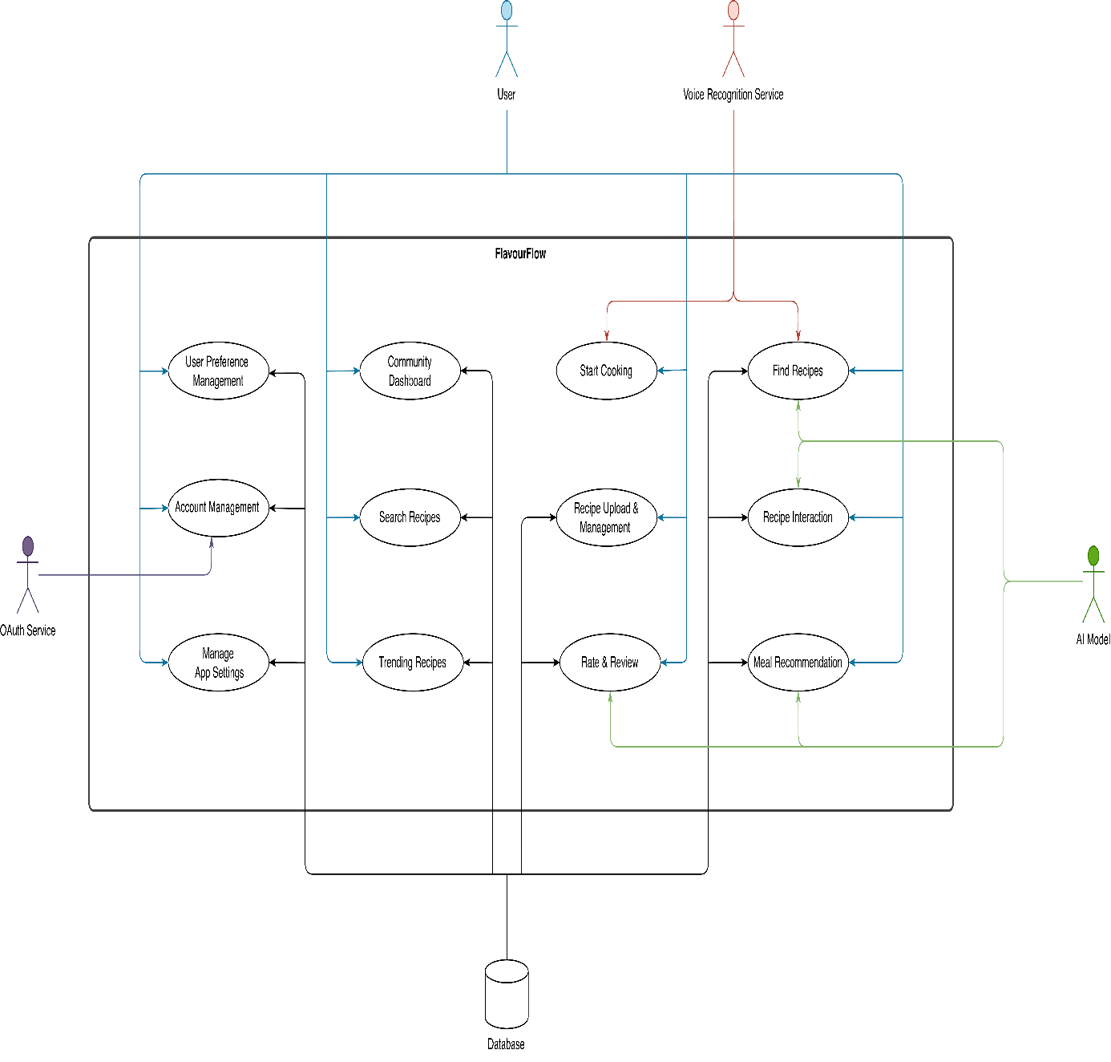
Figure ‎3.1-1: System Use Cases

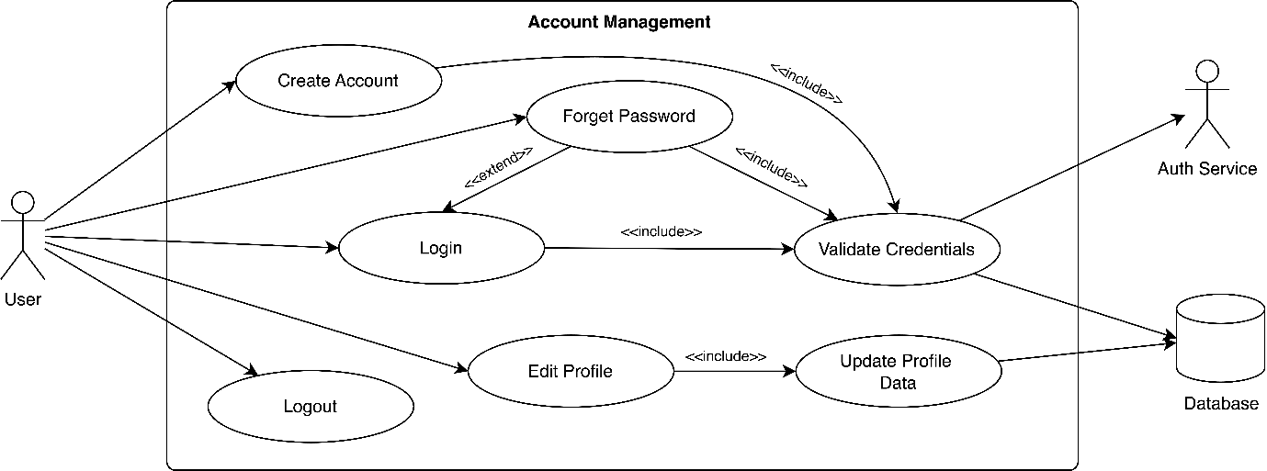
Figure ‎3.1-2: Account Management

Table ‎3.1-1: Use Case – 1: Account Management
Field | Details
Use Case ID | UC_1
Use Case Name | Account Management
Description | This use case covers all functions related to user authentication and profile management.
Primary Actor | User
Secondary Actor(s) | Auth Service, Database
Pre-Condition | User has opened the application and has an internet connection.
Post-Condition | The user's session is securely created, managed, or terminated. The user's profile data is updated.
Basic Flow | 1. The user initiates an authentication action.  2. The user can Create a New Account with their email and password.  3. An existing user can Login.  4. A user can request a Password Reset.  5. Once logged in, the user can Edit their Profile (e.g., change name, photo).  6. A logged-in user can Logout, which securely terminates their session.
Alternate Flow | - If login credentials are invalid, the system displays an "Invalid credentials" error.  - If the user tries to create an account with an email that already exists, the system prompts them to log in instead.  - If the network connection fails, the system displays a "Connection error" message.

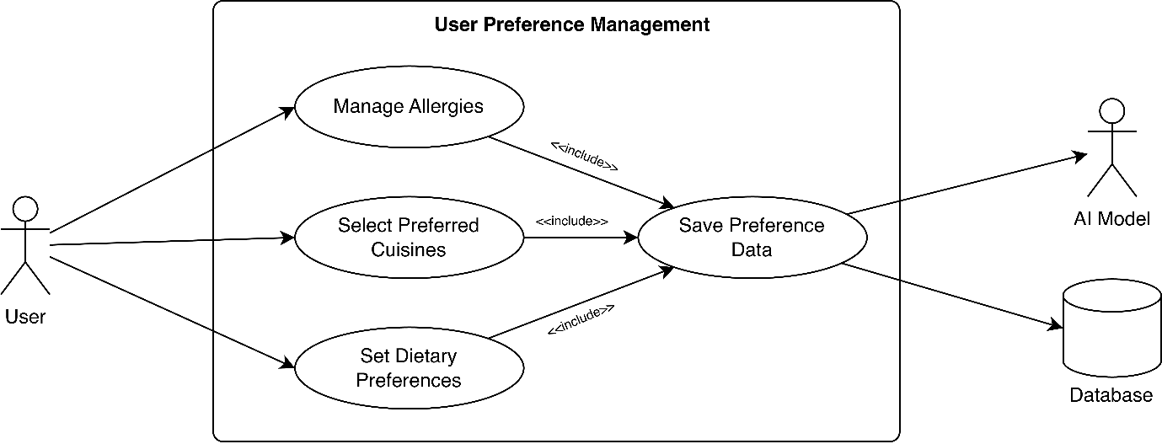
Figure ‎3.1-3: User Preference Management

Table ‎3.1-2: Use Case – 2: User Preference Management:
Field | Details
Use Case ID | UC_2
Use Case Name | User Preference Management
Description | This use case allows the user to set up their culinary profile, which is essential for the AI to provide personalized recommendations.
Primary Actor | User
Secondary Actor(s) | Database, AI Model
Pre-Condition | The user must be logged in.
Post-Condition | The user's preferences (allergies, diet, etc.) are saved to their profile in the database. The AI model is updated.
Basic Flow | 1. The user redirects to the "My Preferences" screen, often after first-time login.  2. The user can Add/Remove Allergies from a predefined list.  3. The user can Select multiple Cuisine Preferences (e.g., Pakistani, Italian).  The user can Update Dietary Preferences (e.g., Vegetarian, Halal, Diabetic-Friendly).  5. The user saves their profile. The AI Model is updated with this new information.
Alternate Flow | - If the user exits without saving, the system asks to confirm discarding changes.

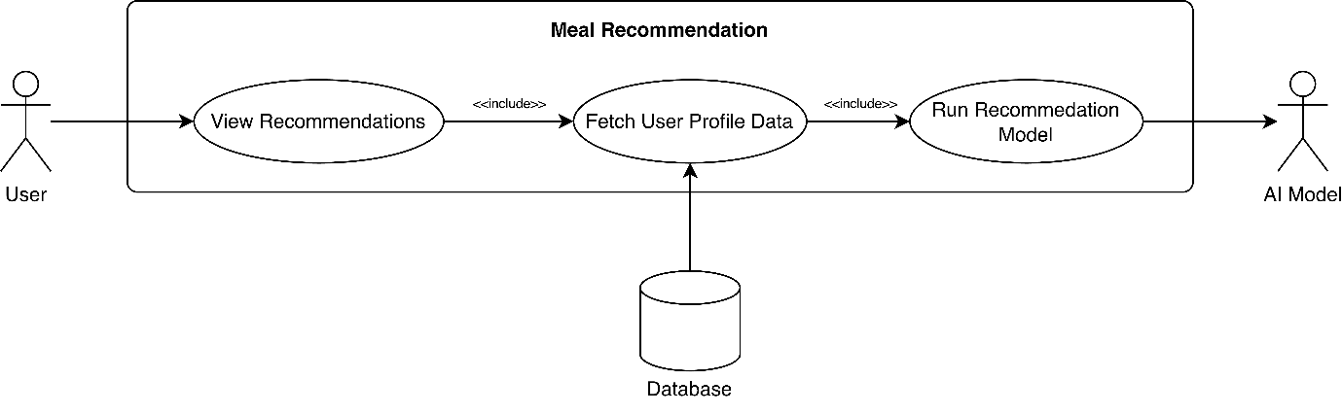
Figure ‎3.1-4: Meal Recommendation

Table ‎3.1-3: Use Case – 3: Meal Recommendation System
Field | Details
Use Case ID | UC_3
Use Case Name | Meal Recommendation
Description | This use case allows the user to view personalized meal recommendations generated by the AI model, based on their stored preferences and past behavior.
Primary Actor | User
Secondary Actor(s) | AI Model, Database
Pre-Condition | The user must be logged in and have saved at least basic preferences.
Post-Condition | A personalized list of recipes is displayed to the user on their home screen.
Basic Flow | 1. The user opens the app's home screen.  2. The system retrieves the user’s profile and relevant data from the Database.  3. The AI Model processes the input data and generates personalized recipe recommendations.  4. The system generates a list of Today's Meals.  5. The system presents personalized Breakfast, Lunch, and Dinner Recommendations.
Alternate Flow | - If the user is new and has no preferences, the system will redirect the user to complete their user preference page.

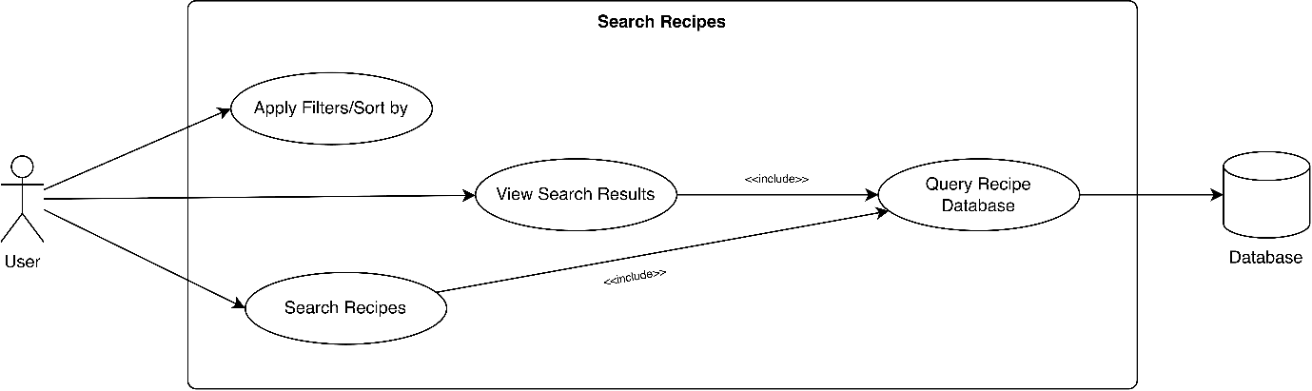
Figure ‎3.1-5: Search Recipes

Table ‎3.1-4: Use Case – 4: Search Recipes
Field | Details
Use Case ID | UC_4
Use Case Name | Search Recipes
Description | This use case provides the tools for users to manually find, filter, sort and view recipes.
Primary Actor | User
Secondary Actor(s) | Database
Pre-Condition | User has an internet connection.
Post-Condition | A list of recipes or a detailed recipe view is displayed to the user according to user filtered preferences.
Basic Flow | 1. The user can Search Recipes by name or ingredient.  2. The user can Filter Recipes (e.g., by cuisine, cook time, dietary need, spiciness-level).  3. The user can Sort Recipes (e.g., by rating, popularity).  4. The user selects a recipe to View Recipe Details (ingredients, steps, video).
Alternate Flow | - If no recipes match the search criteria, the system displays a "No results found" message.

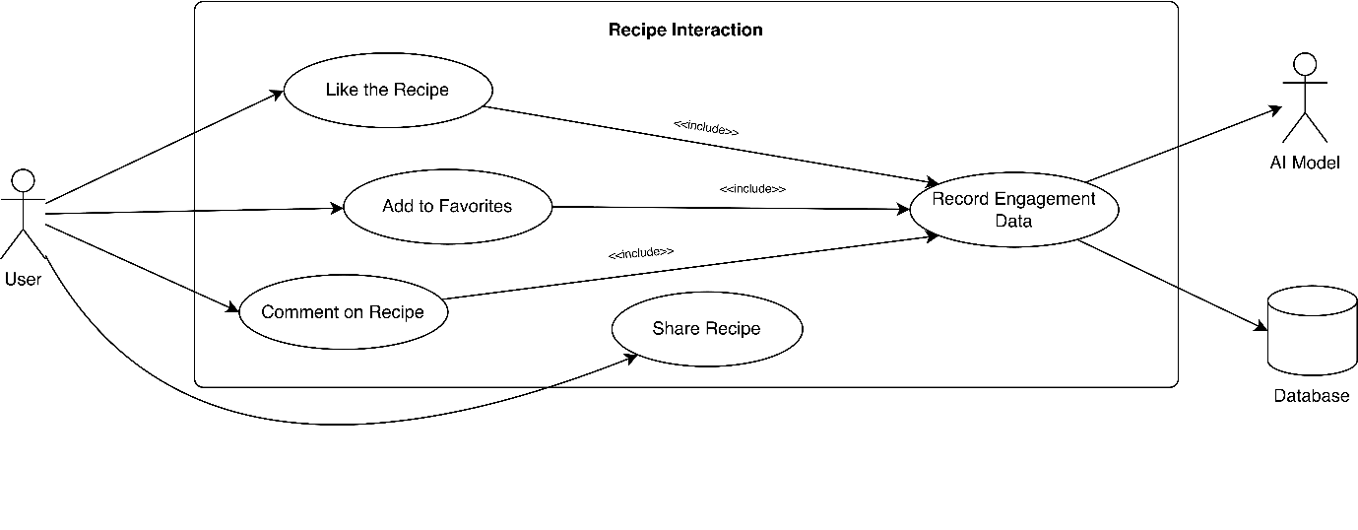
Figure ‎3.1-6: Recipe Interaction
Table ‎3.1-5: Use Case – 5: Recipe Interaction & Engagement
Field | Details
Use Case ID | UC_5
Use Case Name | Recipe Interaction
Description | Allows users to interact with recipe content, providing implicit feedback for the AI and saving content.
Primary Actor | User
Secondary Actor(s) | Database, AI Model
Pre-Condition | The user must be logged in and access/open a recipe.
Post-Condition | All engagement interactions (like, comment, save, share) are stored in the Database and/or sent to the AI Model to improve recommendations.
Basic Flow | 1. The user opens a recipe.  2. The user can Like a recipe.  3. The user can Comment on a recipe.  4. The user can Share a recipe to an external application.  5. The user can Save/Bookmark the recipe to their personal list.  6. The system saves this interaction to the AI Model as implicit feedback by that user.
Alternate Flow | - If the recipe fails to load (e.g., network error), the system displays: “Unable to load recipe. Please check your connection.”

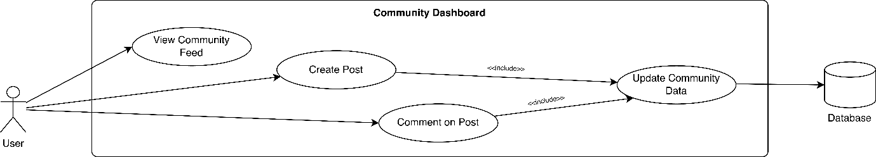
Figure ‎3.1-7: Community Dashboard

Table ‎3.1-6: Use Case – 6: Community Dashboard
Field | Details
Use Case ID | UC_6
Use Case Name | Community Dashboard
Description | A social hub where users can share their cooking experiences and interact with other community members.
Primary Actor | User
Secondary Actor(s) | Database
Pre-Condition | The user must be logged in.
Post-Condition | A new post or comment is created and visible on the feed.
Basic Flow | 1. The user navigates to the "Community" tab.  2. The user can View the Community Feed (a timeline of posts).  3. The user can Create a Community Post (with text and/or images).  4. The user can Comment on a Post made by another user.
Alternate Flow | - If the network connection fails, a "Could not load posts" message is shown.

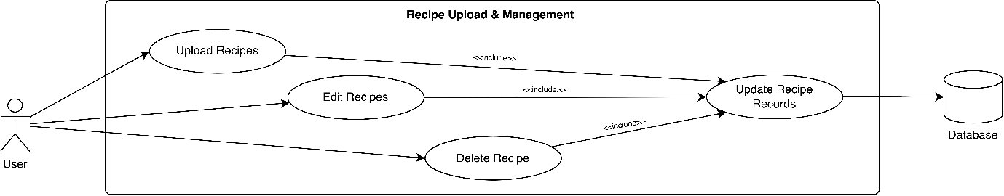
Figure ‎3.1-8: Recipe Upload and Management

Table ‎3.1-7: Use Case – 7: Recipe Upload & Management
Field | Details
Use Case ID | UC_7
Use Case Name | Recipe Upload & Management
Description | Allows users to become creators by uploading their own recipes to the platform via a personal dashboard.
Primary Actor | User
Secondary Actor(s) | Database
Pre-Condition | The user must be logged in.
Post-Condition | A new recipe, submitted by the user, is added to the database and linked to their profile.
Basic Flow | 1. The user navigates to their "My Recipes" dashboard.  2. The user selects "Upload a New Recipe."  3. The user fills out a structured form (title, description, ingredients, steps, image, attachs video link).  4. The user submits the form. The system saves the recipe.  5. The user can later Edit an Uploaded Recipe.  6. The user can Delete an Uploaded Recipe.
Alternate Flow | - If the form validation fails (e.g., missing title), the system displays an error and highlights the required fields.

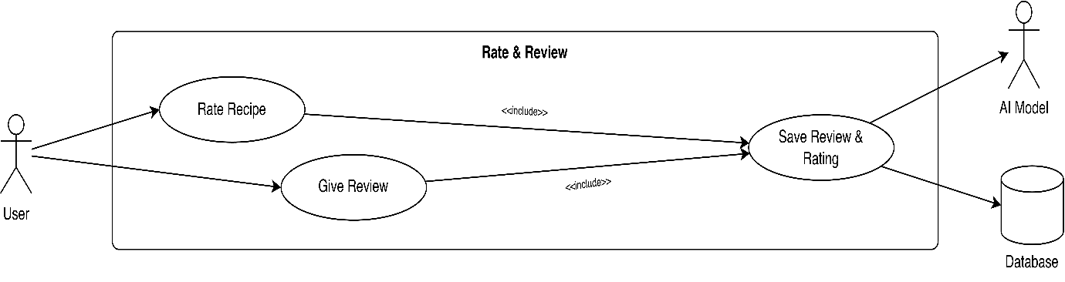
Figure ‎3.1-9: Rate and Review

Table ‎3.1-8: Use Case – 8: Feedback & Rating System
Field | Details
Use Case ID | UC_8
Use Case Name | Rate & Review
Description | The explicit feedback loop for the AI. Allows users to rate and review recipes they have tried.
Primary Actor | User
Secondary Actor(s) | Database, AI Model
Pre-Condition | The user must be logged in and must have cooked the recipe at least once.
Post-Condition | A new rating/review is saved. The AI Model is updated with this explicit feedback.
Basic Flow | 1. The user opens a recipe.  2. The user can Rate a Recipe (1-5 stars).  3. The user can Submit Review (a detailed written review).  4. The system saves the review to the database.  5. The system sends this data to the AI Model to improve future recommendations for the user.
Alternate Flow | - If the system detects that the user has not cooked the recipe before.  The system displays a message:  “You can only give feedback after cooking this recipe at least once.”  The system disables the rating/review form OR redirects the user to “Start Cooking”.

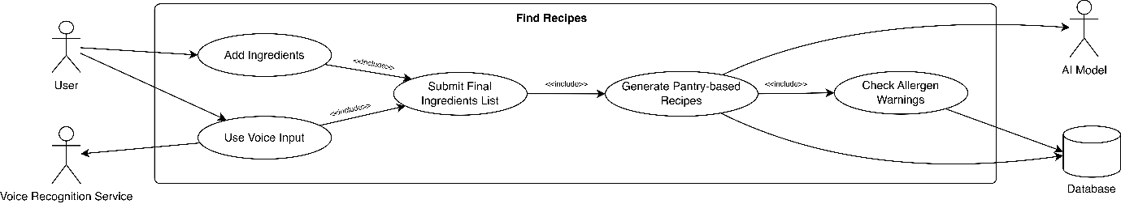
Figure ‎3.1-10: Find Recipes from Ingredients

Table ‎3.1-9: Use Case – 9: Find Recipes from Ingredients
Field | Details
Use Case ID | UC_9
Use Case Name | Find Recipes
Description | The "What's in Your Fridge?" feature. Allows users to get recipes based on ingredients they own.
Primary Actor | User
Secondary Actor(s) | Database, AI Model, Voice Recognition Service
Pre-Condition | The user must be logged in and must have added at least two ingredients before requesting pantry-based recipe suggestions.
Post-Condition | A list of recipes based on the user's ingredients is displayed.
Basic Flow | - The user navigates to the " What's in Your Fridge?”(fridge icon) feature.  - The user can Add Ingredients to Pantry (by typing or selecting mutli-options) or use a Microphone for voice-to-text dictation.  - The user submits their ingredient list.  - The system queries the AI Model and returns Pantry-Based Recipes.  - The system also performs an Allergen Warning check against the user's profile.
Alternate Flow | - If no recipes match the ingredients, the system suggests adding 1-2 more items.

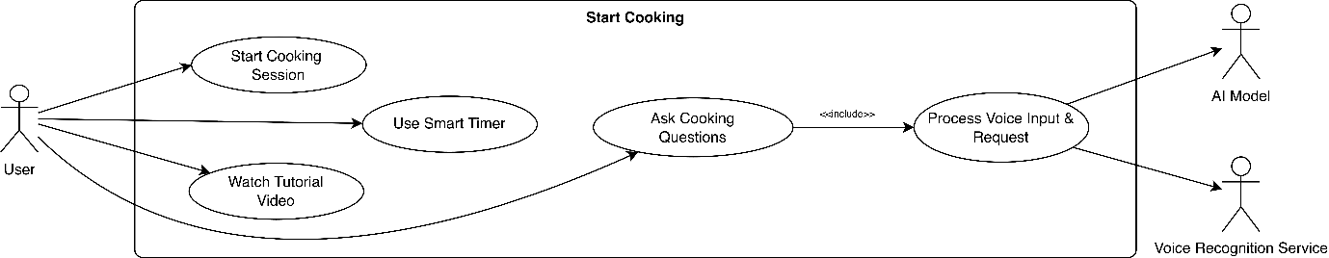
Figure ‎3.1-11: Start Cooking
Table ‎3.1-10: Use Case – 10: Start Cooking
Field | Details
Use Case ID | UC_10
Use Case Name | Start Cooking
Description | Provides a guided, step-by-step experience and input methods to help users while they are actively cooking.
Primary Actor | User
Secondary Actor(s) | Voice Recognition Service ,AI Assistance
Pre-Condition | The user must have opened a recipe detail page i.e., selected a recipe to cook.
Post-Condition | The user is guided through a recipe, or their voice is transcribed to text.
Basic Flow | 1. The user opens a recipe.  2. The user can select "Start Cooking" to launch the Step-by-Step Guide.  3. On a cooking step, the user can Start a Smart Timer.  4. The user can Watch Embedded Video Tutorials for the recipe.  5. When user is cooking, they can take help about cooking by tapping a microphone icon to use Voice-to-Text dictation or can add a text query from AI Cooking Assistance.
Alternate Flow | - If the Voice Recognition Service fails, the system shows an error and prompts the user to type manually.

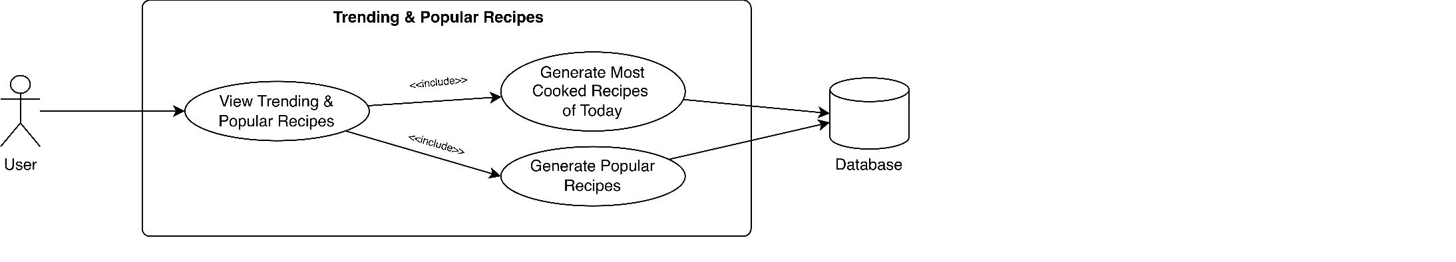
Figure ‎3.1-12: Trending and Popular Recipes

Table ‎3.1-11: Use Case – 11: Trending & Popular Recipe
Field | Details
Use Case ID | UC_11
Use Case Name | Trending & Popular Recipe
Description | A non-personalized discovery module that shows what is popular in the community.
Primary Actor | System
Secondary Actor(s) | User, Database
Pre-Condition | User has an internet connection.
Post-Condition | A list of trending/popular recipes is displayed to the user.
Basic Flow | 1. The user navigates to the "Trending" & “Popular this Week” section on the Home page.  2. The system automatically curates a list of Popular Recipes.  3. The system generates a list of Most Cooked Today (based on all user activity).  4. The user can browse and select these recipes to view their details.
Alternate Flow | - If there is not enough data to generate a list, the system displays a default set of popular recipes.

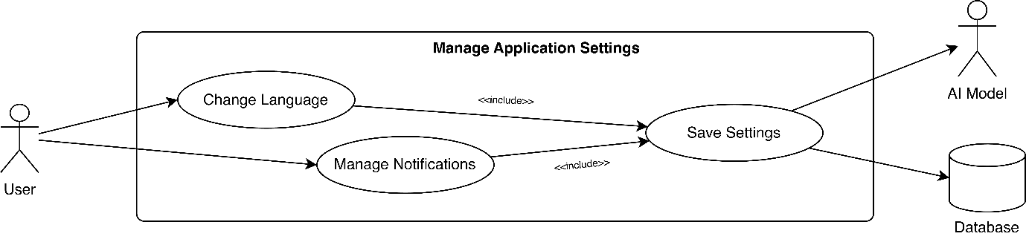
Figure ‎3.1-13: Manage Application Settings

Table ‎3.1-12: Use Case – 12: Manage Application Settings
Field | Details
Use Case ID | UC_12
Use Case Name | Manage Application Settings
Description | Allows users to customize their app experience, including language and notifications.
Primary Actor | User
Secondary Actor(s) | Database
Pre-Condition | The user must be logged in to save settings.
Post-Condition | The application's UI is re-rendered in the selected language, and notification preferences are saved.
Basic Flow | 1. The user navigates to the "Settings" screen.  2. The user can Change Language (from English to Urdu, or vice-versa).  3. The user can Change Notification Settings (e.g., toggle meal reminders on/off).  4. The system saves the user's choices.
Alternate Flow | - N/A

Chapter 4: Design:

Architecture Diagram

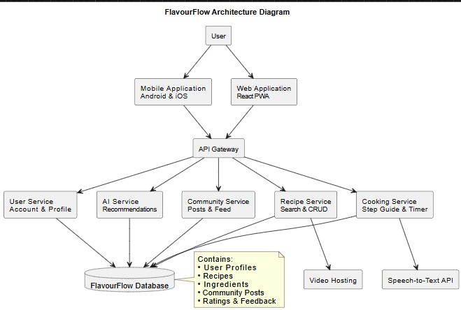

ERD with data dictionary:

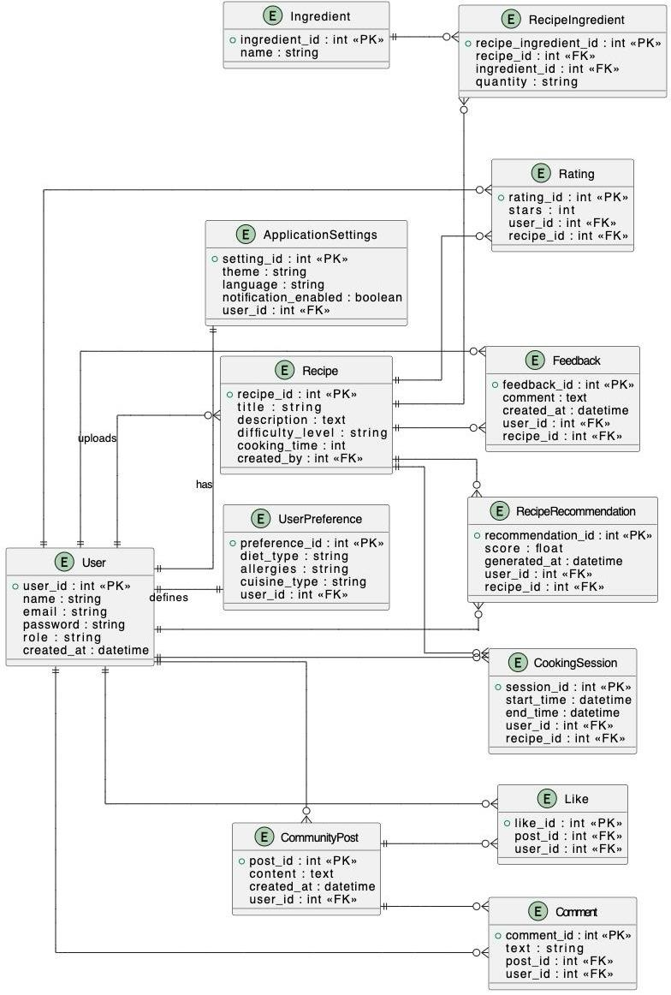

Data Flow Diagram:

The Level 0:
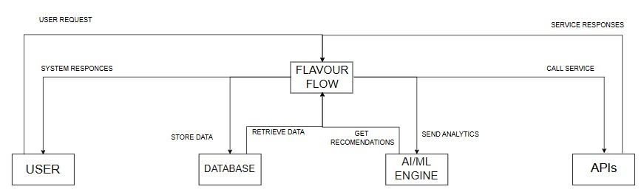

The Level 1:
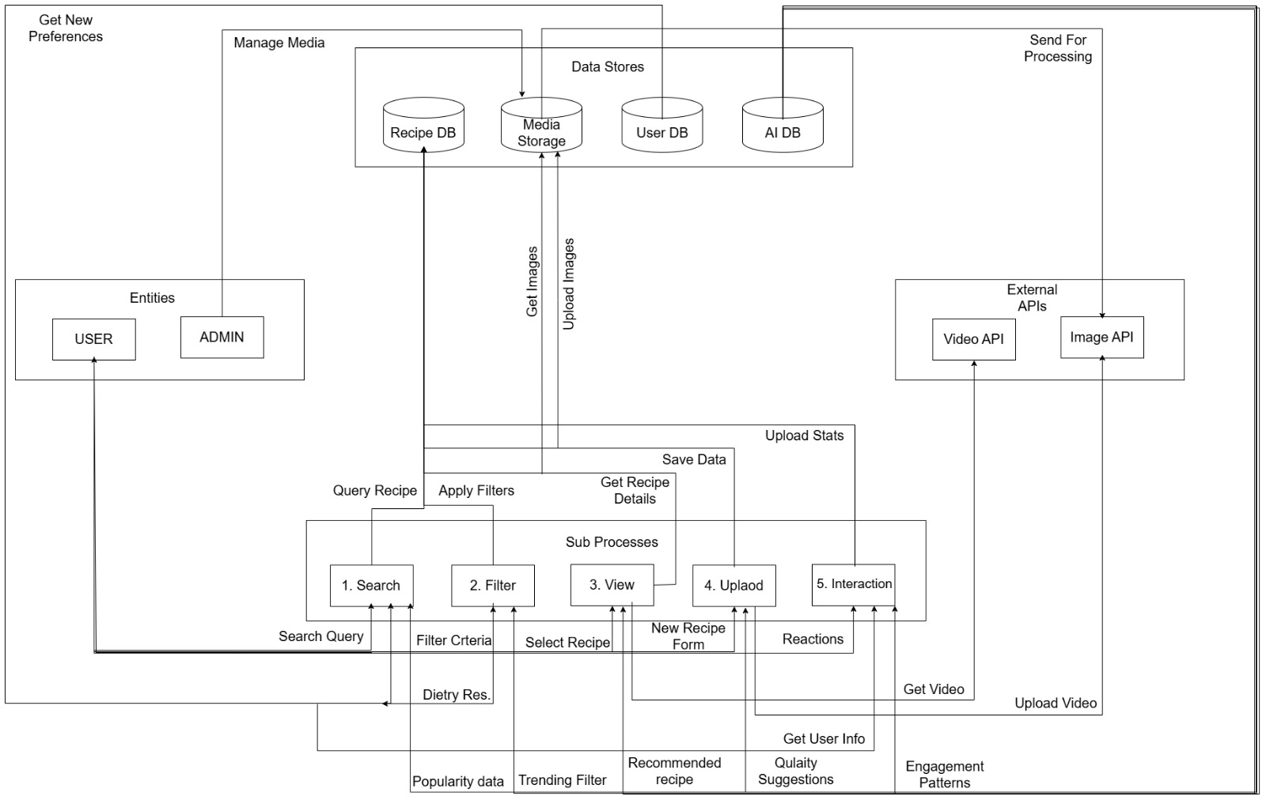

The Level 2:


Class Diagram:

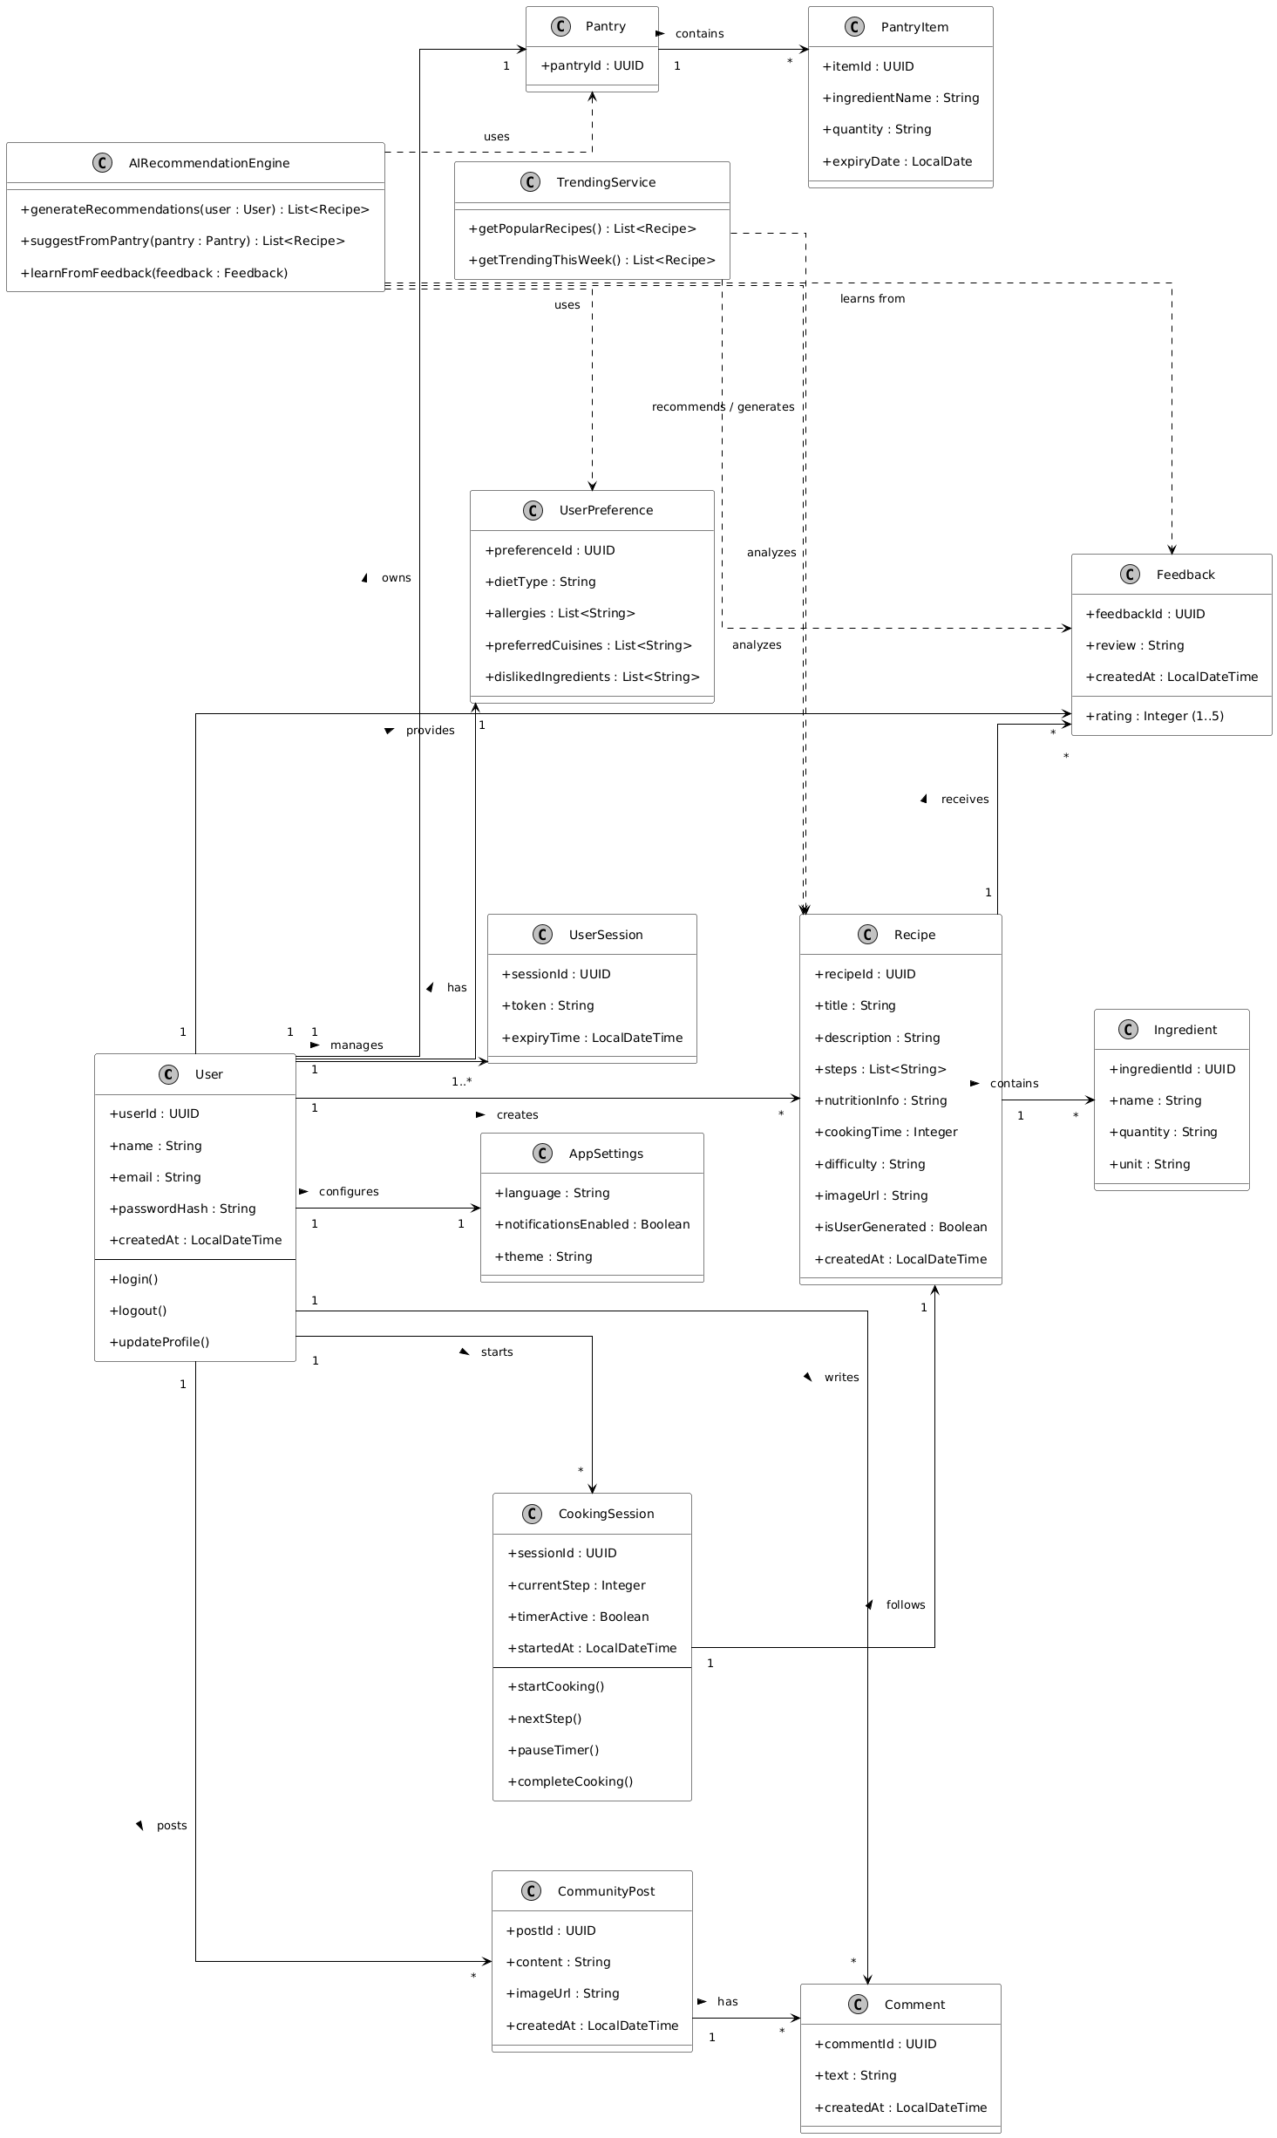

Activity Diagrams:

Account Management
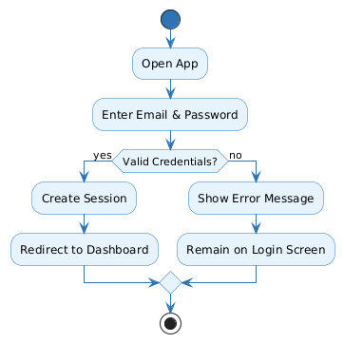

User Preference
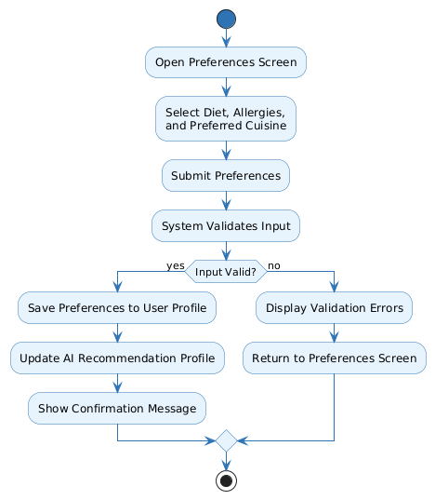

Meal Recommendation
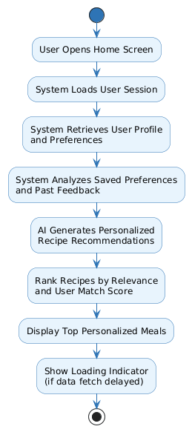

Recipe Interaction
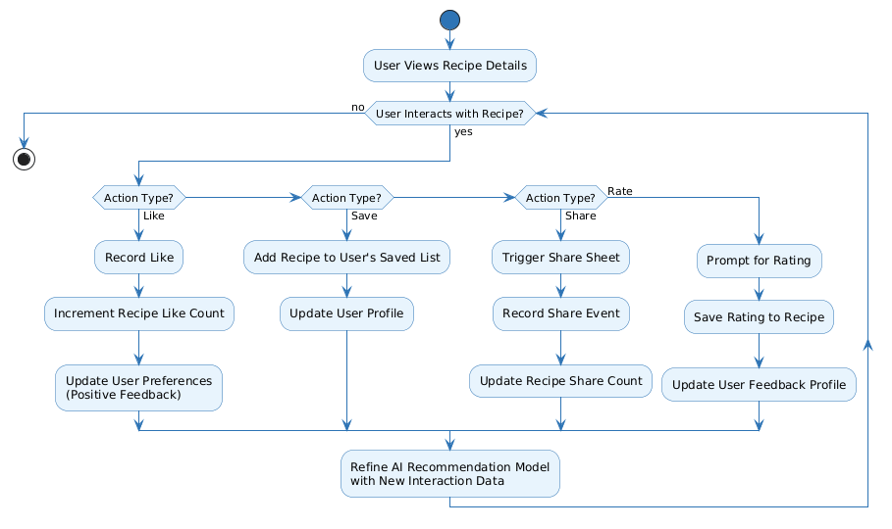

Recipe Search & Discovery
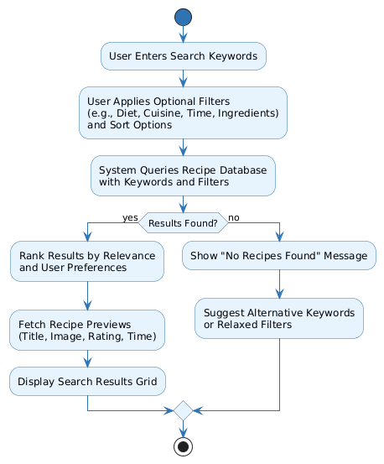

Community Dashboard
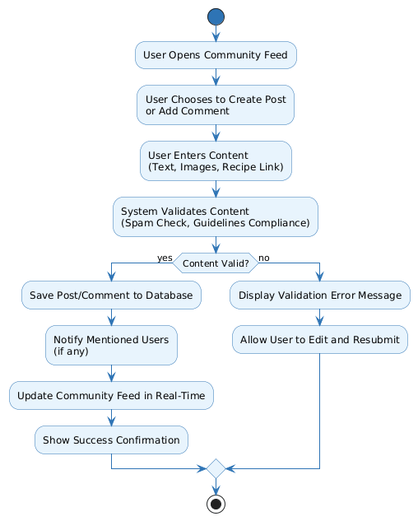

Recipe Upload & Management
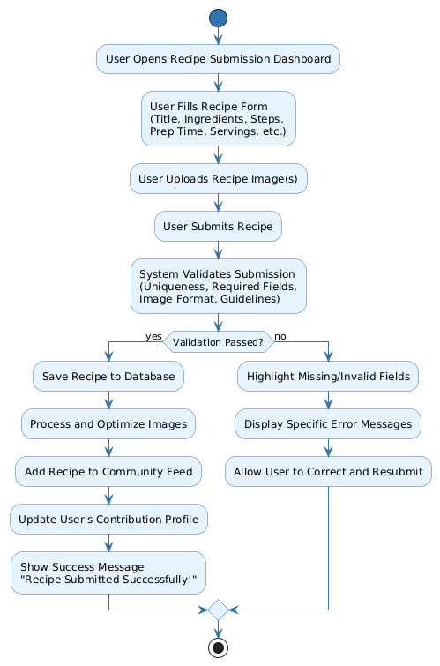

Feedback & Rating
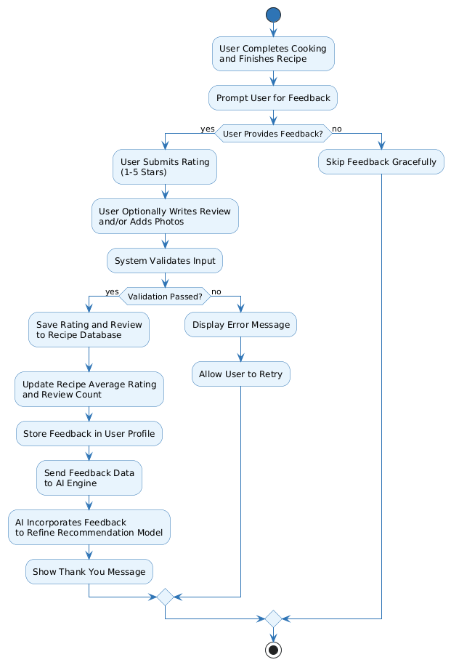

Smart Pantry & Ingredient Insights
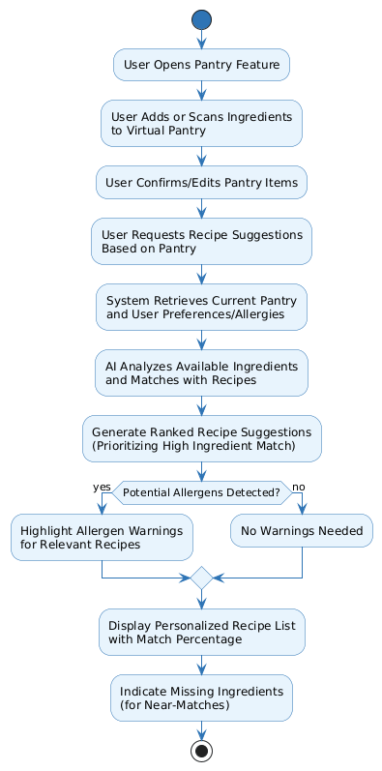

Cooking Assistance
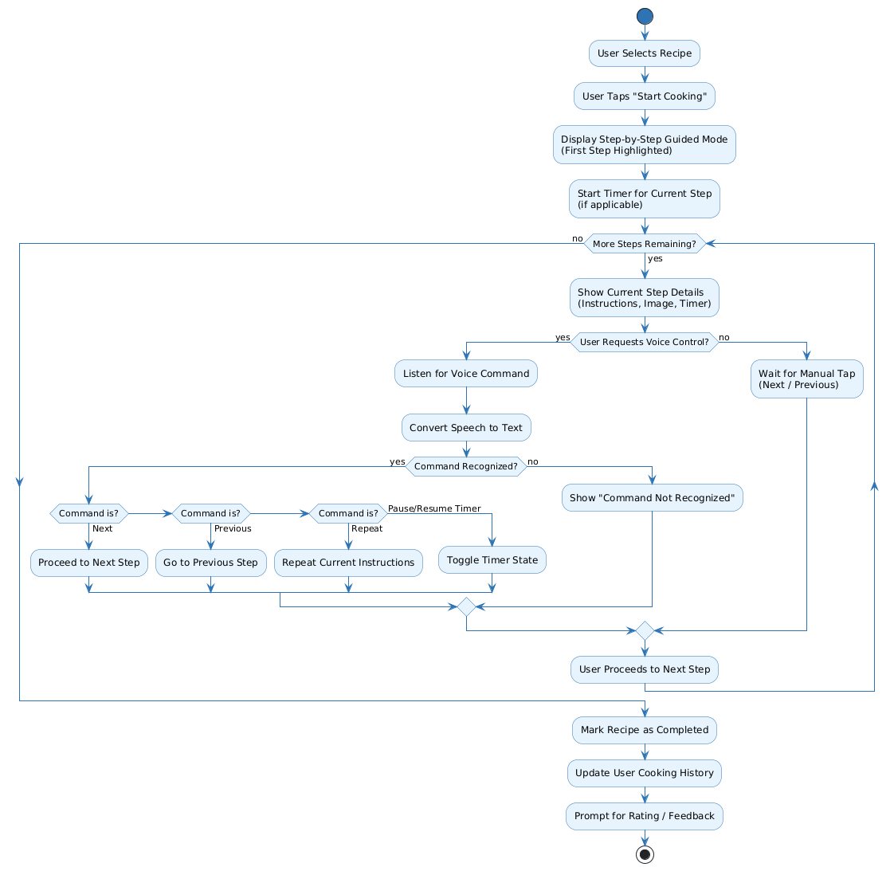

Trending & Popular Recipes
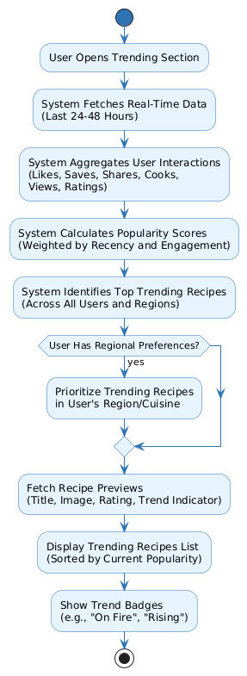

Manage Application Settings
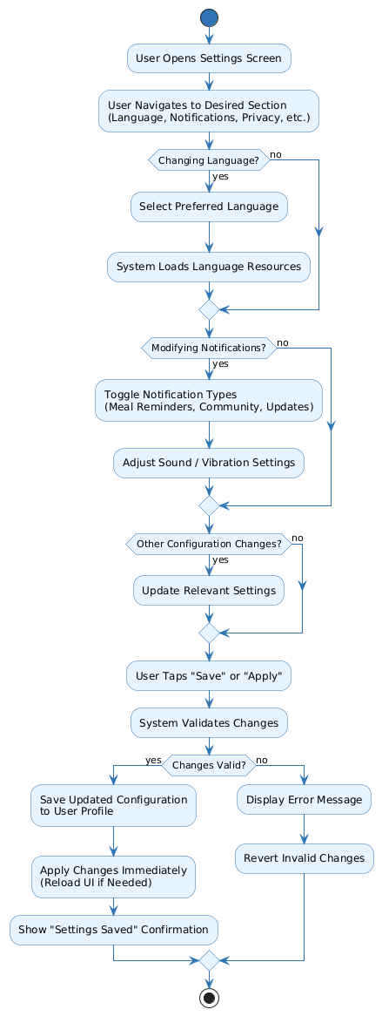

Sequence Diagrams

Account Management
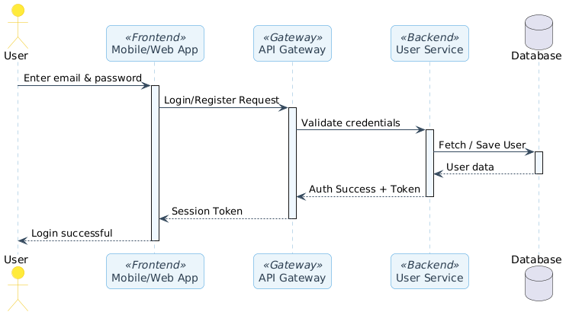

User Preference
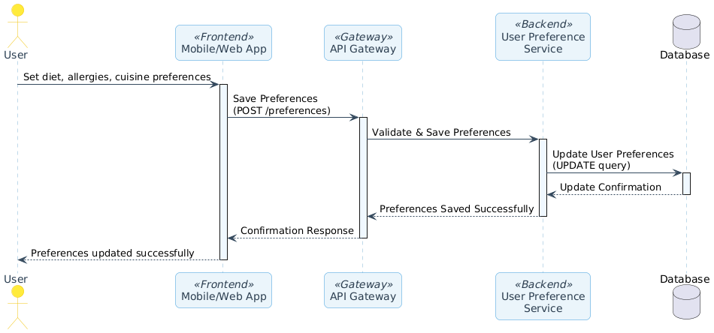

Meal Recommendation
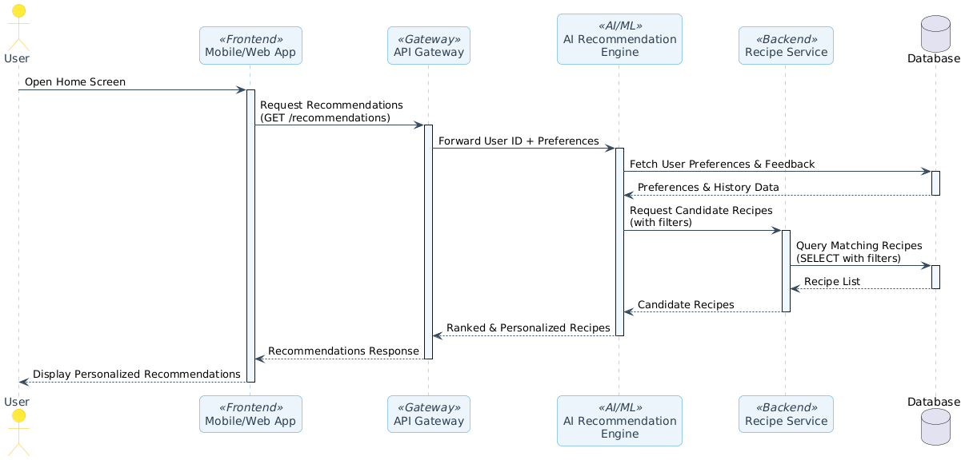

Recipe Interactions
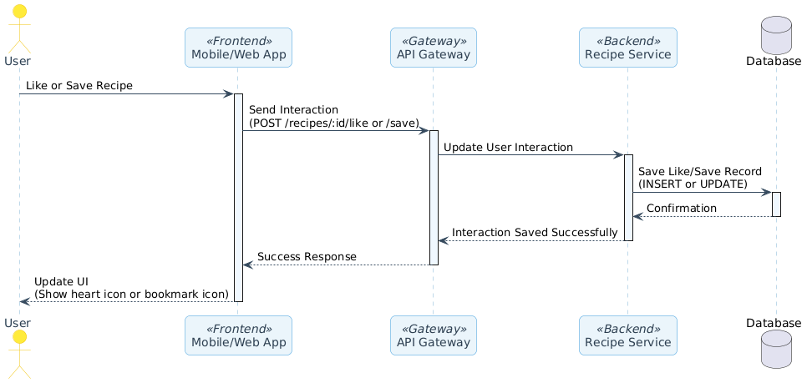

Recipe Search & Discovery
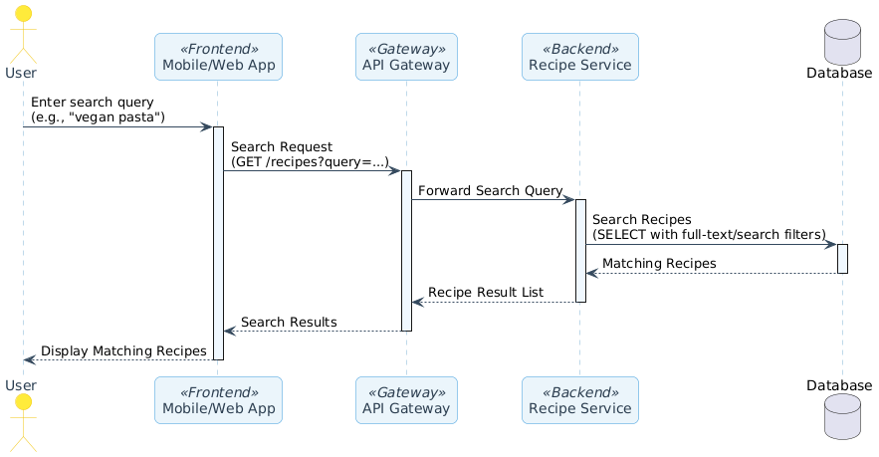

Community Dashboard
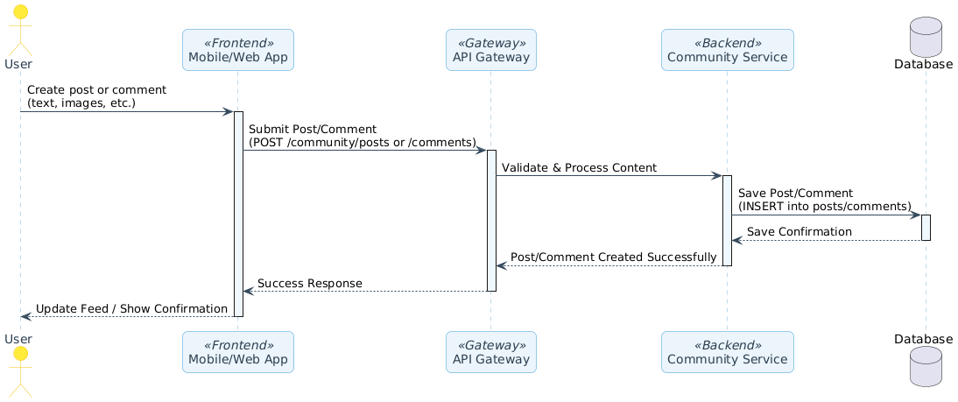

Recipe Upload & Management
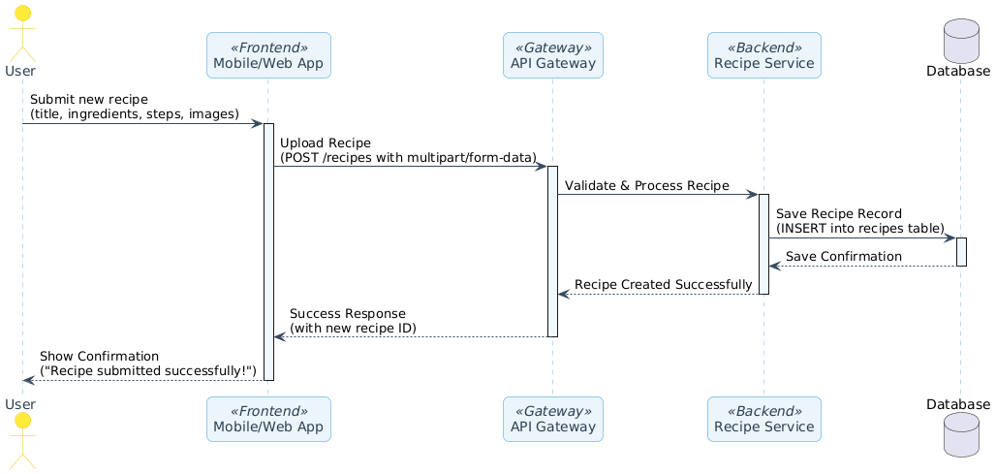

Feedback & Rating
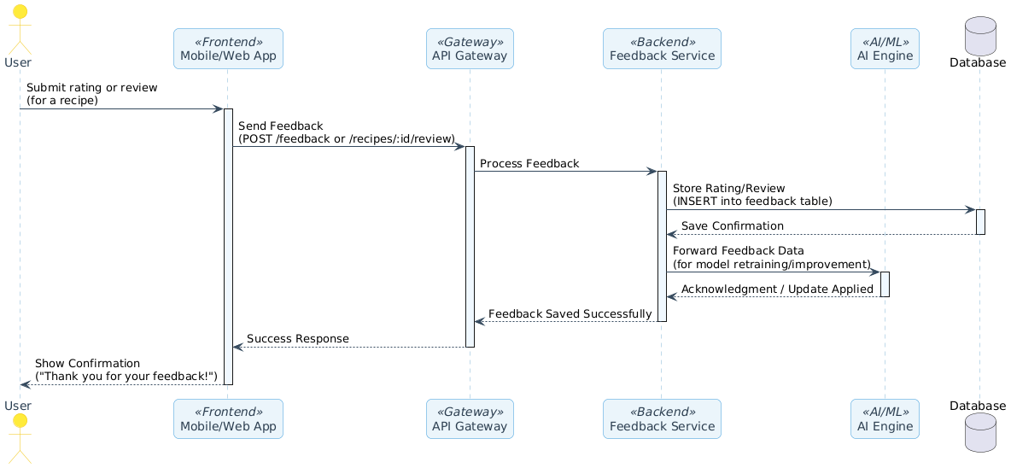

Smart Pantry & Ingredient Insights
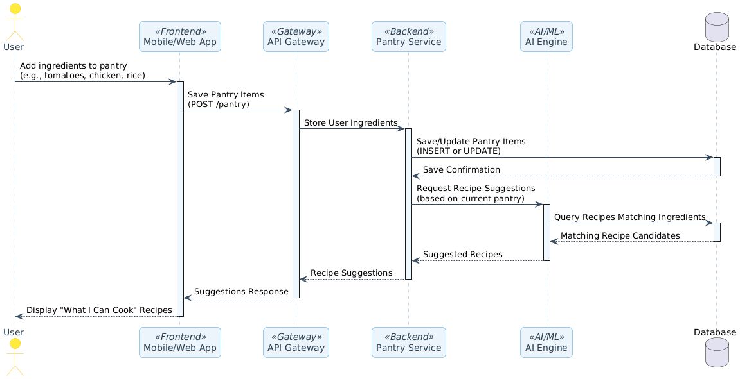

Cooking Assistance
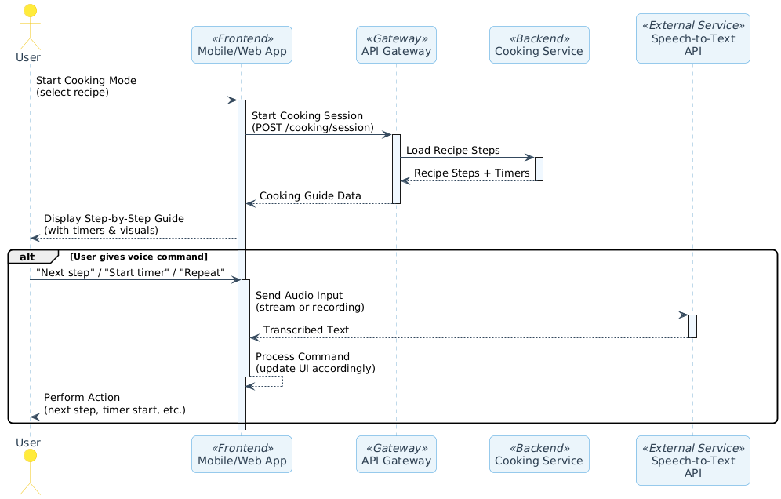

Trending & Popular Recipes
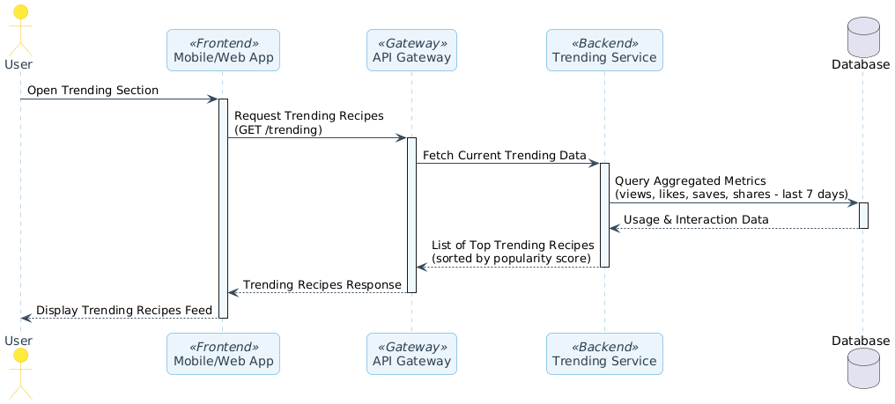

Manage Application Settings
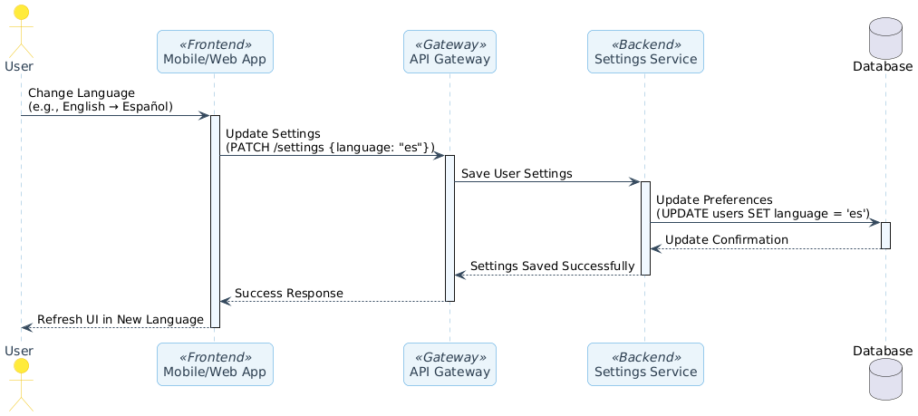

Collaboration Diagrams

Auth

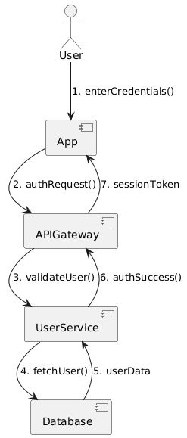

Personalized Meal Recommendation

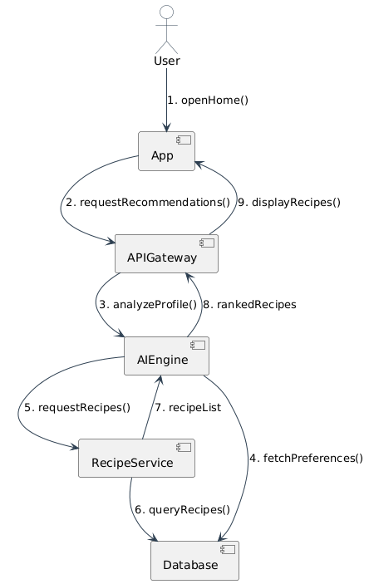

Community Dashboard & Social Feed

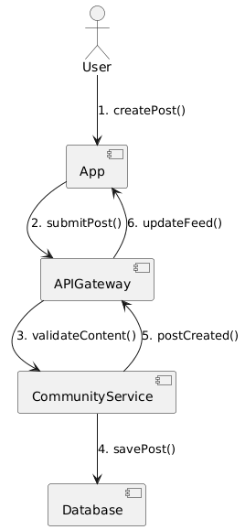

User Recipe

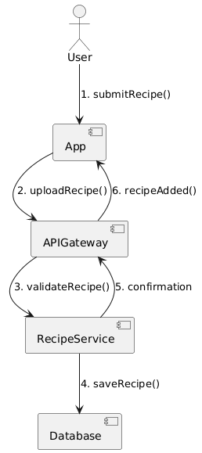

Smart Pantry

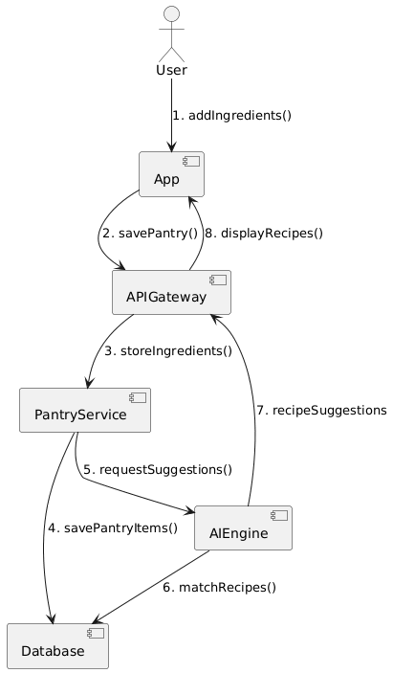

Cooking Assistance

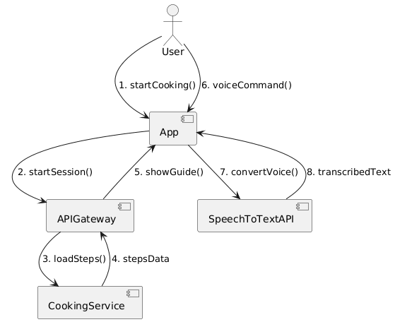

Application Settings & Localization

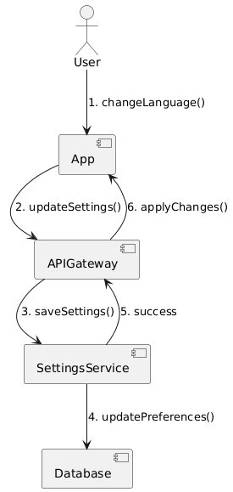

State Transition Diagram

User State Transition
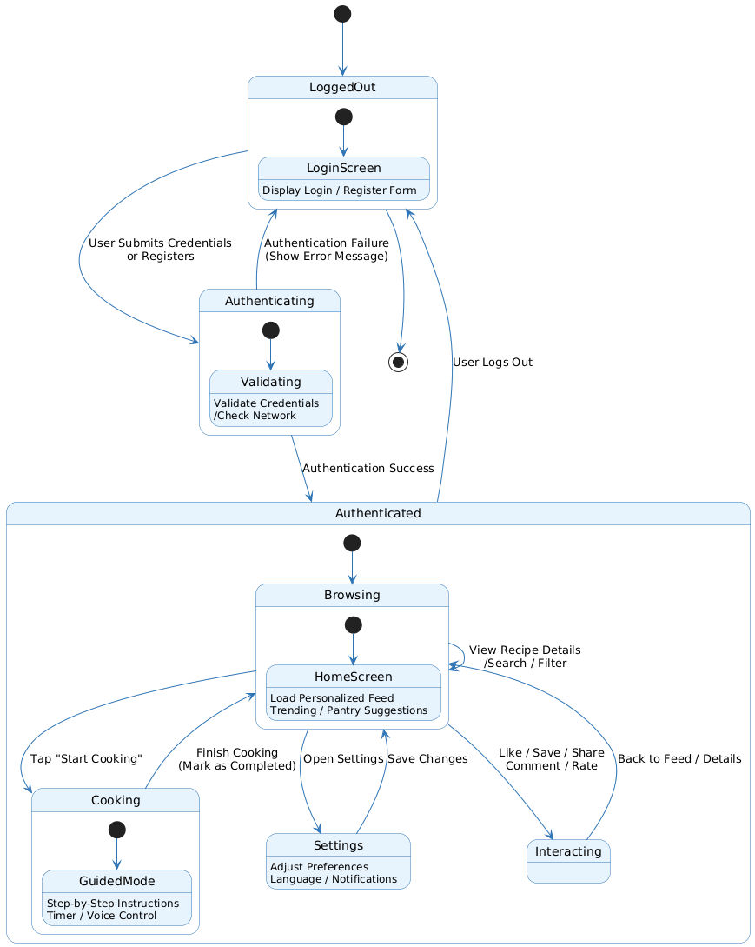

Cooking Session State Transition
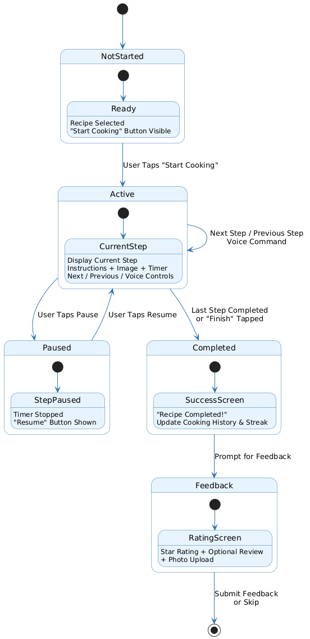

Component Diagram
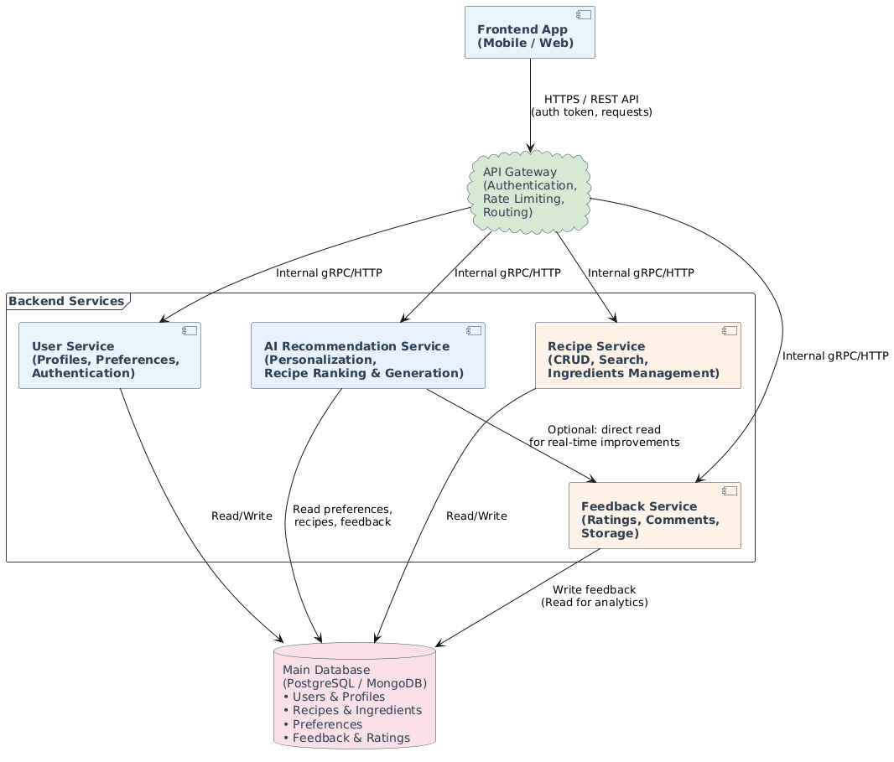

Deployment Diagram
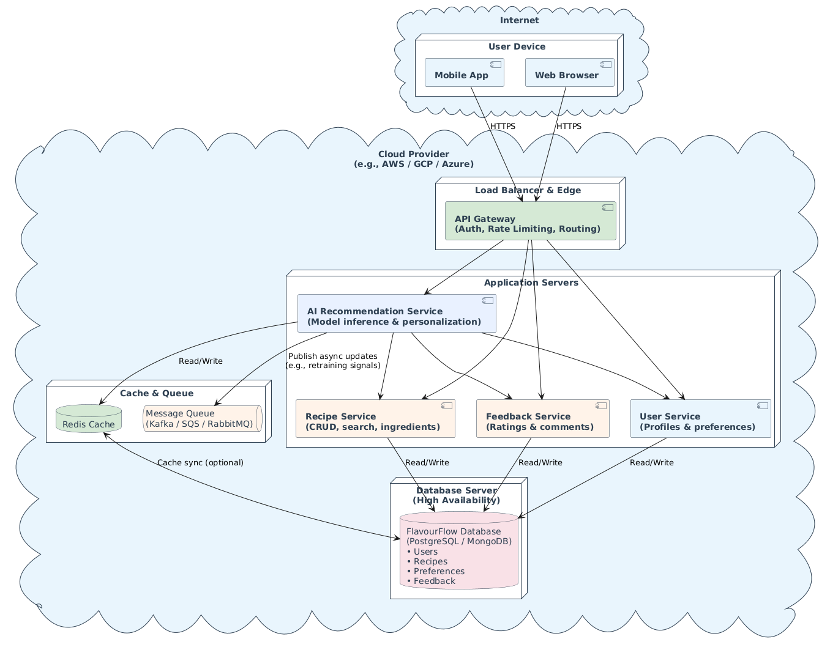

Chapter 5: Testing

Test Case Specifications
This section presents the detailed test case specifications for FlavourFlow's core modules, covering both positive and negative scenarios.

Test Case 1: User Login
Positive Test Case
Field | Details
ID | TC_LOGIN_SUCCESS
Priority | High
Description | Verify successful user authentication
Reference | FR_01 Login Account
Users | Registered User
Pre-requisites | System is online, valid credentials exist
Steps | 1. Open Login Page 2. Enter valid email 3. Enter valid password 4. Click Login
Input | Valid Email and Password
Expected Result | User successfully logs into the system and dashboard opens
Status | Tested, Passed

Negative Test Case
Field | Details
ID | TC_LOGIN_FAILURE
Priority | High
Description | Verify login with invalid credentials
Reference | FR_01 Login Account
Pre-requisites | System is online
Steps | 1. Open Login Page 2. Enter invalid email/password 3. Click Login
Input | Invalid credentials
Expected Result | Error message displayed and access denied
Status | Tested, Passed

Test Case 2: Recipe Search
Positive Test Case
Field | Details
ID | TC_SEARCH_SUCCESS
Priority | High
Description | Verify recipe search functionality
Reference | FR_05 Search Recipes
Pre-requisites | Recipes exist in database
Steps | Search recipe using keyword
Input | "Chicken Biryani"
Expected Result | Matching recipes displayed
Status | Tested, Passed

Negative Test Case
Field | Details
ID | TC_SEARCH_FAILURE
Priority | Medium
Description | Search unavailable recipe
Reference | FR_05 Search Recipes
Pre-requisites | Database available
Input | Random non-existing recipe name
Expected Result | "No Results Found" message displayed
Status | Tested, Passed

Test Case 3: Recipe Recommendation
Positive Test Case
Field | Details
ID | TC_RECOMMEND_SUCCESS
Priority | High
Description | Generate recommendations based on preferences
Reference | FR_03 Meal Recommendation
Pre-requisites | User preferences configured
Input | User preferences
Expected Result | Personalized recipes displayed
Status | Tested, Passed

Negative Test Case
Field | Details
ID | TC_RECOMMEND_FAILURE
Priority | Medium
Description | Generate recommendation without preferences
Reference | FR_03 Meal Recommendation
Pre-requisites | No preferences available
Input | Empty preferences
Expected Result | Default recommendations shown
Status | Tested, Passed

Test Case 4: Smart Pantry
Field | Positive (TC_PANTRY_ADD) | Negative (TC_PANTRY_INVALID)
Priority | Medium | Medium
Description | Add ingredient to pantry | Add invalid/blank ingredient
Reference | FR_09 Smart Pantry | FR_09 Smart Pantry
Input | Rice | Empty value
Expected Result | Ingredient stored successfully | Validation error displayed
Status | Tested, Passed | Tested, Passed

Test Case 5: Recipe Upload
Field | Positive (TC_UPLOAD_SUCCESS) | Negative (TC_UPLOAD_FAILURE)
Priority | High | High
Description | Upload recipe successfully | Upload incomplete recipe
Reference | FR_07 Recipe Upload | FR_07 Recipe Upload
Input | Complete recipe data | Missing title/ingredients
Expected Result | Recipe uploaded successfully | Validation error displayed
Status | Tested, Passed | Tested, Passed

Test Case 6: Feedback & Rating
Field | Positive (TC_RATING_SUCCESS) | Negative (TC_RATING_FAILURE)
Priority | Medium | Medium
Description | Submit recipe rating | Submit invalid rating
Input | Rating = 5 | Rating = 6
Expected Result | Rating stored successfully | Error message displayed
Status | Tested, Passed | Tested, Passed

Black Box Testing

Equivalence Partitioning (EP)
Variable | Valid Classes | Invalid Classes
Email | Proper email format (user@domain.com) | Missing @ symbol
Password | Length >= 6 characters | Length < 6 characters
Rating | 1 – 5 (inclusive) | Less than 1 or greater than 5
Search Query | Existing recipe keyword | Empty query
Pantry Item | Valid ingredient name | Blank field

Boundary Value Analysis
Password Validation
Input Length | Result
5 characters | Invalid
6 characters | Valid (boundary)
7 characters | Valid

Rating Validation
Rating Value | Result
0 | Invalid
1 | Valid (lower boundary)
5 | Valid (upper boundary)
6 | Invalid

Decision Table Testing
Login Authentication
Email | Password | Expected Result
Correct | Correct | Login Successful
Correct | Incorrect | Error Message Displayed
Incorrect | Correct | Error Message Displayed
Incorrect | Incorrect | Error Message Displayed

State Transition Testing
User Session States
Current State | Event | Next State
Logged Out | Login (valid) | Logged In
Logged In | Logout | Logged Out
Logged In | Session Timeout | Logged Out
Logged Out | Invalid Login Attempt | Logged Out

Use Case Testing
Upload Recipe Use Case
Step | Action
1 | User opens upload page
2 | User enters recipe details
3 | User uploads image
4 | User submits recipe
Expected Result | Recipe stored in database successfully

White Box Testing

Cyclomatic Complexity
Login Authentication Module
Control Flow: Start → Validate Input → Authenticate User → Dashboard

Decision Points: Input Validation, Authentication Verification

Cyclomatic Complexity Formula: V(G) = Number of Decision Nodes + 1
V(G) = 2 + 1 = 3

Interpretation: The Login Module has a cyclomatic complexity value of 3, indicating low complexity and easy maintainability. This value confirms that all independent paths through the login logic can be covered with three test cases.

Performance Testing
Performance testing was conducted to evaluate system responsiveness and stability under normal operating conditions.

Module | Expected Response Time | Actual Response Time | Result
Login | < 2 sec | 1.2 sec | Pass
Search Recipe | < 3 sec | 1.8 sec | Pass
Recipe Recommendation | < 5 sec | 3.1 sec | Pass
Recipe Upload | < 4 sec | 2.7 sec | Pass
Pantry Management | < 2 sec | 1.0 sec | Pass

Result: The system responded efficiently under normal operating conditions. All modules met their defined performance thresholds.

Stress Testing
Stress testing was performed by simulating multiple user requests simultaneously to evaluate system stability under load.

Test Scenario:
- 100 concurrent users
- Continuous recipe searches
- Multiple recipe uploads
- Concurrent recommendation requests

Expected Result: System remains operational without crashes.
Actual Result: The system maintained acceptable performance and no major failures were observed.
Status: Passed

System Testing
System testing was conducted to verify complete integration of all modules through an end-to-end scenario.

End-to-End Scenario:
- User Registration
- User Login
- Preference Setup
- Recipe Recommendation
- Recipe Search
- Smart Pantry Management
- Recipe Upload
- Feedback Submission
- Logout

Expected Result: All modules communicate successfully and complete user workflow executes without errors.
Result: System passed all end-to-end integration tests.

Regression Testing
Regression testing was conducted after implementation of new features such as Smart Pantry and Personalized Recommendations to ensure no previously working functionality was broken.

Selecting Regression Tests
The following modules were selected:
- User Authentication
- Recipe Search
- Recipe Upload
- Feedback System
- Recommendation Engine

Selection Criteria:
- Frequently used features
- Business-critical modules
- Previously modified modules

Regression Testing Steps
- Select affected modules.
- Execute previously passed test cases.
- Compare current results with expected results.
- Identify defects introduced by new changes.
- Fix defects and retest.
- Approve release after successful execution.

Regression Testing Result: No existing functionality was affected after implementation of new features. All regression tests passed successfully.

Chapter 6: Tools and Techniques
This chapter provides a detailed overview of all programming languages, frameworks, development tools, cloud services, libraries, and third-party integrations used in the development of FlavourFlow. Each tool was selected based on its suitability for cross-platform mobile development, AI integration, performance, and scalability requirements.

Programming Languages
Tool / Technology | Version / Type | Purpose
TypeScript | 5.x | Primary language for the React Native frontend; provides static typing and improved code maintainability
Python | 3.11+ | Used for all backend services, AI/ML model logic, REST API development, and data processing pipelines
JavaScript | ES2022 | Used alongside TypeScript for configuration files, utility scripts, and React Native tooling

TypeScript
TypeScript was chosen as the primary frontend language due to its strong static typing system, which significantly reduces runtime errors in a complex application with many interconnected components. It improves developer productivity through better IDE support, autocompletion, and early error detection during compilation. TypeScript compiles down to standard JavaScript and integrates seamlessly with the React Native ecosystem.

Python
Python was used for all server-side logic due to its extensive ecosystem of AI and machine learning libraries. The backend REST API, the AI recommendation engine, pantry-based recipe matching logic, and data processing pipelines were all implemented in Python. Its readability and rapid development capabilities made it ideal for iterative development within the project timeline.

Frameworks and Libraries
Tool / Technology | Version / Type | Purpose
React Native | 0.73+ | Cross-platform mobile UI framework for building native iOS and Android apps from a single codebase
Expo | SDK 50 | Toolchain built on React Native; simplifies device API access, builds, and over-the-air updates
FastAPI | 0.110+ | High-performance Python web framework used to build the backend REST API
TensorFlow / Keras | 2.x | Used for training and serving the AI-based meal recommendation model
Pandas & NumPy | Latest stable | Data manipulation and numerical computation for AI data preprocessing pipelines
Scikit-learn | 1.x | Provides collaborative filtering and content-based filtering utilities for recipe recommendations

React Native
React Native enables the development of a single application codebase that compiles to native iOS and Android applications. This was a critical choice for FlavourFlow, as it allowed the team to maintain one frontend codebase while delivering a fully native user experience on both platforms. React Native's component-based architecture promotes code reuse and modular design.

FastAPI
FastAPI was selected for the backend API due to its asynchronous request handling capabilities, automatic OpenAPI documentation generation, and high-performance benchmarks. It provides a clean and intuitive way to define REST endpoints with full type validation via Pydantic models, aligned with the project's maintainability requirements.

Authentication Services
Tool / Technology | Version / Type | Purpose
Firebase Authentication | v9 (Modular) | Provides secure email/password login, Google OAuth, and session token management
Clerk | Latest | Alternative authentication provider evaluated for pre-built UI components and multi-factor authentication support

Firebase Authentication was selected as the primary provider due to its deep integration with the Firebase ecosystem and reliable SDK support for React Native. It handles secure session token issuance, password reset flows, and social login (Google OAuth) out of the box.

Database and Cloud Infrastructure
Tool / Technology | Version / Type | Purpose
DataStax Astra DB | Cloud (Serverless Cassandra) | Primary cloud database for storing user profiles, recipes, pantry data, community posts, and AI feedback
Supabase | Latest (PostgreSQL) | Used for real-time data, user data storage, community feed updates, and live trending recipe counters
Supabase Storage | Latest | Cloud object storage for user-uploaded recipe images, profile photos, and community post media

Supabase
Supabase was used alongside DataStax as an open-source backend-as-a-service platform built on PostgreSQL. It provides real-time data subscriptions, a built-in REST API, and integrated file storage through Supabase Storage. The Community Dashboard's live feed and the trending recipe counters leverage Supabase's real-time capabilities, pushing updates to connected clients instantly without requiring manual polling.

Development Tools and IDEs
Tool / Technology | Version / Type | Purpose
Visual Studio Code | Latest | Primary code editor for frontend (TypeScript/React Native) and backend (Python) development
Android Studio | Hedgehog+ | Used for Android emulator testing, debugging native Android modules, and APK build configuration
XCode | 15+ | Used for iOS simulator testing, debugging native iOS modules, and IPA build configuration
Postman | Latest | API testing tool used to test and document all FastAPI backend endpoints during development
Git & GitHub | Latest | Version control system and remote repository platform for collaborative team development

UI/UX Design Tools
Tool / Technology | Version / Type | Purpose
Figma | Web-based | Used for wireframing, UI design mockups, and interactive prototyping of all application screens
React Native Paper | 5.x | Material Design component library used for consistent UI elements across the application
React Navigation | 6.x | Navigation library for managing screen transitions, tab navigation, and stack navigation in the app

Figma was used throughout the design phase to create high-fidelity UI mockups for all 12 functional modules before implementation began. This allowed the team to validate the user experience design early and avoid costly redesigns during development.

Artificial Intelligence and Machine Learning Tools
Tool / Technology | Version / Type | Purpose
TensorFlow / Keras | 2.x | Deep learning framework used for building and training the personalized recipe recommendation model
Scikit-learn | 1.x | Used for collaborative filtering and content-based filtering algorithms
NLTK / spaCy | Latest stable | Natural language processing libraries used for ingredient parsing and voice-to-text query processing
OpenAI API / Gemini API | Latest | Used to power the AI Cooking Assistance chatbot feature within the Start Cooking module

The AI recommendation system uses a hybrid approach combining collaborative filtering (based on similar user behavior) and content-based filtering (based on ingredient and cuisine preferences). The model is trained on anonymized user interaction data including ratings, saves, and cooking completions. The OpenAI or Gemini API powers the conversational AI Cooking Assistance feature, allowing users to ask free-text questions about their current recipe during the cooking process.

Testing Tools
Tool / Technology | Version / Type | Purpose
Jest | 29.x | JavaScript testing framework used for unit and integration testing of React Native components
Pytest | 7.x | Python testing framework used for unit testing of all FastAPI backend endpoints and AI logic
Detox | 20.x | End-to-end testing framework for React Native, used for automated UI testing on real devices and emulators
Postman / Newman | Latest | Used for automated API collection testing and regression testing of backend endpoints

Summary of Tools and Technologies
Category | Tools / Technologies | Platform
Programming Languages | TypeScript, Python, JavaScript | Cross-platform
Frontend Framework | React Native, Expo | iOS & Android
Backend Framework | FastAPI (Python) | Cloud / Server
Authentication | Firebase Auth, Clerk | Cloud
Primary Database | Supabase (PostgreSQL) | Cloud (Serverless)
Real-time & Storage | Supabase Storage | Cloud
AI / ML | TensorFlow, Scikit-learn, OpenAI/Gemini API | Cloud / On-device
NLP | NLTK, spaCy | Server-side
UI Components | React Native Paper, React Navigation | Mobile
Design | Figma | Web-based
IDEs | VS Code, Android Studio, Xcode | Desktop
Version Control | Git, GitHub | Cloud
Testing | Jest, Pytest, Detox, Postman | Cross-platform

Chapter 7: Summary and Conclusion

Summary
FlavourFlow is an AI-powered cross-platform mobile application developed to address the daily challenges of meal planning and cooking, particularly within the Pakistani household context. The project was conceptualized to bridge the gap between existing international cooking platforms and the unique cultural, dietary, and linguistic needs of users in Pakistan. The application was built using React Native for a unified cross-platform frontend experience, with Python-based FastAPI backend services, Firebase/Clerk for authentication, and DataStax Astra DB as the primary data store.
Throughout the development lifecycle, the team successfully implemented the twelve functional requirements defined in the Software Requirement Specification. These include Account Management, User Preference Management, AI-based Meal Recommendation, Recipe Search and Discovery, Recipe Interaction and Engagement, Community Dashboard, User Recipe Upload and Management, Feedback and Rating System, Smart Pantry and Ingredient Insights, Cooking Assistance with step-by-step guidance, Trending and Popular Recipe Display, and Application Settings with Urdu language support.
The Smart Pantry feature — branded as "What's in Your Fridge?" — allows users to input available ingredients and receive tailored recipe suggestions, reducing food waste and simplifying daily cooking decisions. The AI recommendation engine was designed to continuously learn from user ratings, saved recipes, and cooking history, providing an increasingly personalized experience over time. The Community Dashboard enables users to share recipes, post photos, and interact with others, fostering a social cooking environment unique to the FlavourFlow platform.
From a technical standpoint, the project demonstrated a practical implementation of machine learning-driven personalization within a mobile context. The team adopted an agile development methodology, which allowed iterative improvements throughout the project lifecycle. The system was designed to be scalable and maintainable, following SOLID principles and cloud-native patterns to support up to 100,000 concurrent users as defined in the non-functional requirements.

7.2 Conclusion
The development of FlavourFlow has been a comprehensive learning experience that brought together multiple domains of computer science including mobile application development, artificial intelligence, database engineering, and user experience design. The project successfully demonstrates how modern AI technologies can be applied to solve a real, everyday problem for a culturally specific user base.

Despite the challenges encountered during development — particularly in backend and database integration, where ensuring consistent data synchronization between the AI model, user profiles, and the DataStax cloud database required significant effort — the team was able to deliver a functional and feature-rich application. These challenges were overcome through careful architectural decisions, iterative testing, and collaborative problem-solving.
FlavourFlow meets the core objectives set at the outset of the project. It provides an intelligent, user-centric cooking companion that respects Pakistani food culture, supports the Urdu language, accounts for halal and dietary requirements, and makes cooking more accessible for students, busy parents, and novice cooks alike. The application stands out against existing solutions by offering a combination of AI personalization, social community features, and culturally relevant content that no single existing platform currently provides.
In conclusion, FlavourFlow represents a meaningful contribution to the domain of AI-powered lifestyle applications. The project not only fulfills the academic requirements of the Final Year Project but also holds genuine commercial potential as a deployable product for the Pakistani market and the broader South Asian user base. The team is confident that with further development, FlavourFlow can grow into a widely adopted culinary platform.


Chapter 8: User Manual:


User Manual Visual Prototype:







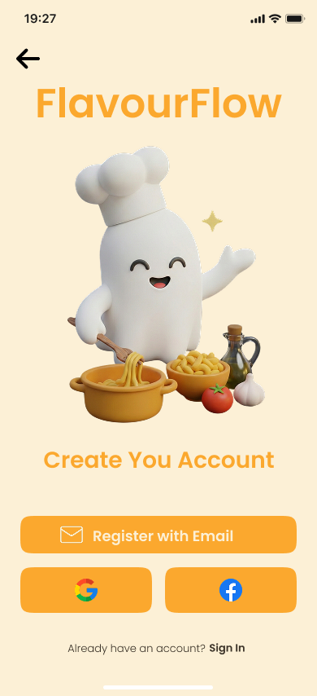



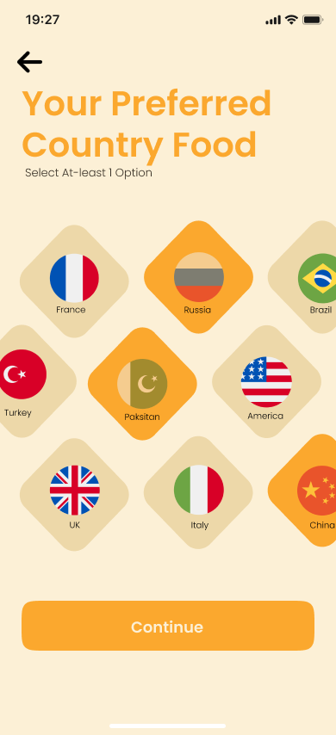


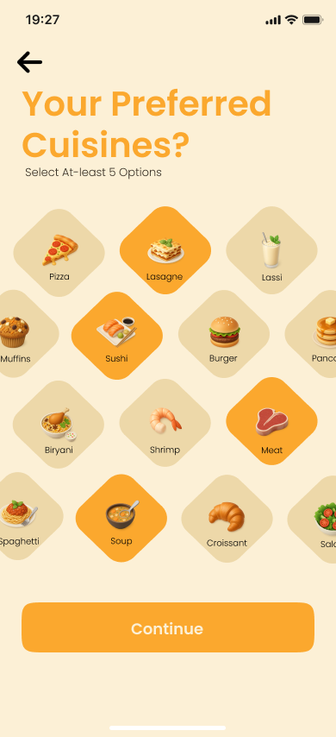
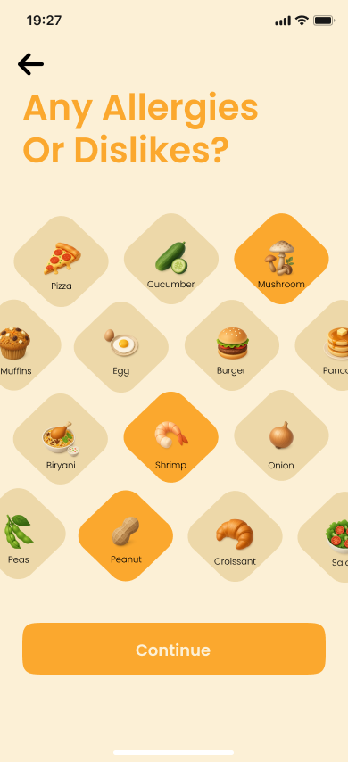
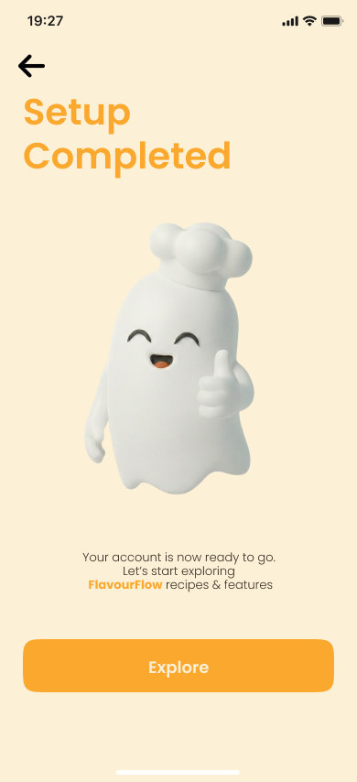
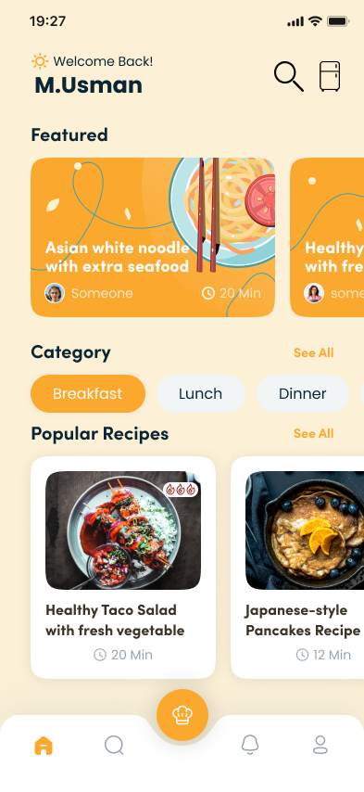

Chapter 9: Lessons Learnt and Future Work

Lessons Learnt
The development of FlavourFlow provided the team with a wide range of practical and technical lessons that go well beyond the classroom. Working on a full-scale application from requirements gathering through to implementation exposed the team to the real-world complexity of software engineering. The following are the key lessons learnt throughout the project:

Database Architecture Requires Early and Careful Planning
One of the most significant challenges the team faced was related to backend and database integration. Integrating DataStax DB with real-time AI recommendation logic required a well-thought-out schema from the very beginning. Early design decisions that seemed minor — such as how user preferences, recipe metadata, and interaction history were stored — had cascading effects on query performance and AI accuracy later in development. The lesson learned is that database architecture must be treated as a first-class concern from day one, not an afterthought.
Cross-Platform Development Has Hidden Complexity
While React Native provides a powerful framework for building both iOS and Android applications from a single codebase, the team discovered that platform-specific behavior differences — particularly around navigation, camera access, and voice input — required additional handling. This taught the team the importance of testing on both platforms continuously throughout development rather than only at the end.
AI Personalization Requires Sufficient and Quality Data
Building the AI recommendation engine highlighted how dependent machine learning models are on data quality and quantity. During early testing, recommendation quality was poor due to a limited seed dataset. The team learned that designing a robust data collection and feedback loop — through ratings, saves, and cooking completions — is just as important as the model architecture itself. Garbage in, garbage out is a principle that became very real during this project.
Agile Methodology Improves Adaptability
Adopting an agile development approach allowed the team to adapt to changing requirements and unexpected technical blockers without derailing the entire project. Breaking the work into focused sprints and regularly reviewing progress helped maintain momentum and ensured that the most critical features were always prioritized. This was especially valuable when database issues threatened to delay the project timeline.
User Experience is as Important as Functionality
Throughout usability reviews, the team found that features which worked perfectly from a technical standpoint sometimes frustrated users due to poor interface design. This reinforced the understanding that functionality alone does not make a good application — the user interface must be intuitive, accessible, and responsive. Designing for non-technical users, such as older family members unfamiliar with smartphones, required a fundamentally different approach to layout and interaction design.
Documentation Should Be Written Alongside Development
The team found that attempting to write documentation after the fact was significantly harder and more error-prone than maintaining it alongside the development process. Details about design decisions, API contracts, and data flows that seemed obvious during implementation were difficult to reconstruct later. Going forward, the team recognizes the value of treating documentation as a continuous deliverable throughout the software development life cycle.

Future Work
While FlavourFlow has achieved its core objectives as defined in Version 1.0 of the project, there remain several exciting directions for future development that would significantly enhance the application's capabilities and user reach. The following features and improvements are planned for post-FYP iterations:

Real-Time Voice-Activated Cooking Assistant
The most immediate and impactful planned enhancement is the development of a fully real-time, hands-free voice-activated cooking assistant. The current version of FlavourFlow includes voice-to-text input for search and pantry management, but future iterations will extend this into a continuous, conversational AI assistant that actively communicates with the user while they cook. The assistant will be capable of reading out recipe steps on command, responding to natural language queries such as "how long should I fry the onions?" or "what's the next step?", managing timers through voice commands, and providing substitution suggestions when an ingredient is unavailable. This feature will be particularly valuable for users with limited mobility, users cooking with wet or oily hands, and visually impaired users, making FlavourFlow a genuinely inclusive cooking companion.
Community Moderation System
As the FlavourFlow community grows, a robust moderation framework will become essential to maintaining content quality and user safety. Future development will introduce reporting mechanisms, automated content filtering for inappropriate posts, and a moderation dashboard for administrators. This will ensure that the Community Dashboard remains a positive and trustworthy space for users to share their cooking experiences.
AI-Powered Nutritional Tracking and Health Insights
A future version of the application will incorporate detailed nutritional tracking, allowing users to log meals and monitor their daily intake of calories, macronutrients, and micronutrients. The AI engine will use this data to further refine recipe recommendations, particularly for users with specific health goals such as weight management, diabetes control, or high-protein dietary plans. Integration with health platforms such as Apple Health and Google Fit is also envisioned.
Ingredient Scanning via Augmented Reality (AR)
Rather than requiring manual text input, a future Smart Pantry feature will allow users to scan their refrigerator or pantry shelves using their smartphone camera. Using computer vision and AR technology, the application will automatically identify ingredients and populate the pantry list. This will dramatically reduce the friction of using the Smart Pantry feature and make it more accessible to a wider range of users.
Expanded Language Support
While the current version supports English and Urdu, future iterations will expand language support to include regional languages such as Punjabi, Sindhi, and Pashto, broadening FlavourFlow's accessibility across Pakistan. The architecture has been designed with localization in mind, making this a relatively straightforward extension in future development cycles.

